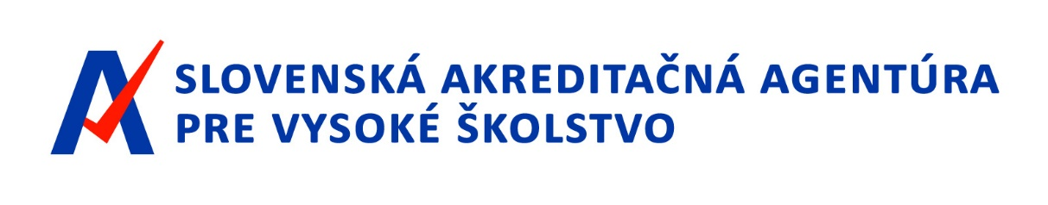
Annual activity and economy report of
Slovak Accreditation Agency for Higher Education in 2019

Bratislava, 18 June 2020

CONTENT

INTRODUCTION 3
1. AGENCY AUTHORITIES 3
1.1. Chair and Vice-Chair of the Executive Board 4
1.2. Executive Board 4
1.3. Members of the Executive Board in 2019 4
1.4. Agency Opposition Assessment Board 5
1.5. Agency Controller 5
1.6. Head of Agency 5
2. INSTITUTIONAL BUILDING OF THE AGENCY 6
2.1. Internal Rules and Regulations 6
2.2. Organisational structure of the Agency and personal provision 7
2.2.1. Agency Office 7
2.2.2. Department of Accreditation Activities 8
2.2.3. Department of Methodological-analytical Activities 8
2.3. Spatial provision of the Agency 8
3. PREPARATION OF ACCREDITATION STANDARDS AND RULES 9
4. LIST OF REVIEWERS 11
5. MEETINGS OF THE EXECUTIVE BOARD IN 2019 11
6. TAKING OVER THE ACCREDITATION COMMISSION AGENDA 14
7. INTERNATIONAL AGENCY ACTIVITIES 15
8. FINANCING AND MANAGEMENT OF THE AGENCY 16
8.1. Analysis of revenues and costs of provided funds for the year 2019 16
8.1.1. Source of Agency´s revenues for 2019 16
8.1.2. Funds provided 16
8.1.3. Disbursement of funds until 31.12.2019 17
8.1.4. Disbursement of funds until 31.03.2020 19
8.2. Condition and movement of property (Property Balance) 23
8.3. Financial flow analysis (Financial Results) 26
8.4. Recapitulation of clearing with the state budget 28
8.5. Control Activities 29
8.5.1. Statement of the Agency Controller 29

INTRODUCTION
Slovak Accreditation Agency for Higher Education (hereinafter referred to as the “Agency”) was established by Act no. 269/2018 Coll. on Quality Assurance in Higher Education and on the amendment of Act no. 343/2015 Coll. on public procurement and on change and amendments to certain laws as amended (hereinafter referred to as the “Quality Act“) on November 1, 2018, as a public body based in Bratislava that carries out external assurance activities quality of higher education.
The mission of the Agency is to contribute to improving the quality of higher education through modern tools following the European Standards for Quality Assurance in Higher Education (ESG 2015). At the same time, it is also providing a professional and independent view of the quality of higher education in the Slovak Republic, thereby strengthening the culture of quality in higher education institutions.
The activities of Agency in 2019 were mainly focused on constituting the institutions' Agency authorities, the institutional building of the Agency, preparation of accreditation standards, evaluation methodology, preparation and approval of the Agency's internal rules and regulations, explanation of changes in quality assurance in higher education for academics and the general public, preparation and implementation of the call for registration in the list of reviewers, preparation of training for reviewers of the Agency and for actions related to the taking over of the agenda and the replacement of activities of Accreditation Commission, an advisory body of the Government of the Slovak Republic (hereinafter referred to as the “Accreditation Commission ”) in assessing higher education applications for accreditation and transfer of competence relevant decision-making authority of the Minister of Education, Science, Research and Sports of the Slovak Republic. Last year, the Agency also carried out a consultation on the quality assurance system of higher education with stakeholders and consultation with foreign experts on the optimal set up the Agency's internal quality system.
1. AGENCY AUTHORITIES
The Agency authorities consist of:
a) Chair of the Executive Board,
b) Vice-Chair of the Executive Board,
c) the Executive Board,
d) Agency Opposition Assessment Board (hereinafter referred to as the „Board of Appeal“),
e) Agency Controller,
f) Head of Agency.

1.1. Chair and Vice-Chair of the Executive Board

The Chair of the Executive Board shall be the statutory body of the Agency, directing the Agency, acting on its behalf, and representing it externally. The Chair of the Executive Board shall be represented in his absence by the Vice-Chair of the Executive Board. The Chair and Vice-Chair of the Executive Board are appointed and excluded by the Minister of Education, Science, Research, and Sports of the Slovak Republic (hereinafter referred to as the "Minister of Education").

Minister of Education JUDr. Mgr. Martina Lubyová, PhD., entrusted the performance of the powers of the Chair of the Executive Board Ing. Martin Kuba until the appointment of the first Chair of the Executive board.

In February 2019, based on the results of the selection procedure, Prof. Ing. Robert Redhammer, PhD. was appointed by the Chair of the Executive Board.

On the proposal of the Chair of the Executive Board, prof. Mgr. René Matlovič, PhD., LL.M., who was appointed a member of the Executive Board of the Agency on the proposal of the Slovak Rectors Conference.

1.2. Executive Board
The Executive Board has nine members, including the Chair and Vice-Chair of the Executive Board. The members of the Executive Board are appointed and excluded by the Minister of Education. The Minister of Education appoints two members on the proposal of the Council of Higher Education Institutions of the Slovak Republic and two members on the proposal of the Slovak Rectors Conference from persons who are internationally recognized experts in their field, two members on the proposal of the Student Council of Higher Education Institutions and two members on the proposal of employers' representatives; the ninth member is the Chairman of the Executive Board.
The powers of the Executive Board are defined in Section 7 of the Quality Assurance Act.

1.3. Members of the Executive Board in 2019
Chair of the Executive Board: prof. Ing. Robert Redhammer, PhD.
Vice-Chair of the Executive Board: prof. RNDr. René Matlovič, PhD., LL.M.

Members of the Executive Board:
prof. Július Horváth, PhD., appointed on the proposal of the Student Council of Higher Education Institutions, a term of office from 15 March 2019 to 14 March 2023;

prof. RNDr. František Kačík, PhD., appointed on the proposal of the Student Council of Higher Education Institutions, a term of office from 15 March 2019 to 14 March 2023;

Ing. Viliam Kupec, PhD., appointed on the proposal of the Student Council of Higher Education Institutions, a term of office from 15 March 2019 to 14 March 2023;

Mgr. art. Bálint Lovász, appointed on the proposal of the Student Council of Higher Education Institutions, a term of office from 15 March 2019 to 14 March 2025;

prof. PaedDr. Vladimír Patráš, CSc., appointed on the proposal of the Student Council of Higher Education Institutions, a term of office from 15 March 2019 to 14 March 2021;

prof. MUDr. Iveta Šimková, CSc., appointed on the proposal of the Student Council of Higher Education Institutions, a term of office from 15 March 2019 to 14 March 2021;

prof. JUDr. Ivan Šimovček, CSc., appointed on the proposal of the Student Council of Higher Education Institutions, a term of office from 15 March 2019 to 14 March 2025.

1.4. Agency Opposition Assessment Board
The Agency Opposition Assessment Board (hereinafter referred to as the „Board of Appeal“) shall examine the procedures of the Executive Board and the working groups of the Executive Board of the Agency on the basis of objections lodged by a party to decisions or observations of the Executive board. The Board of Appeal has five members and two alternates, who are appointed and excluded by the Minister of Education. The term of office of the members of the commission is four years. In June 2019, the Ministry of Education announced a competition for the positions of five members of the Board of Appeal and two alternates. Successful applicants will be appointed by the Minister of Education in 2020.
1.5. Agency Controller
The controller is appointed on the basis of the results of the selection procedure and dismissed by the Minister of Education. The term of the office of the controller is four years. The successful candidate for the position of the controller will be appointed by the Minister of Education in 2020.

1.6. Head of Agency
The Head of Agency shall, in particular, ensure the proper running of the Agency, including the administrative, technical, spatial, and staffing of the Agency, and shall manage the Agency's office to the extent determined by the Chairman of the Executive Board. The Head of Agency shall be appointed and excluded by the Chairman of the Executive Board on the basis of the results of the selection procedure. In 2019, until the appointment of the first head, he was entrusted with the performance of the duties of head of the office Ing. Martin Kuba. Based on the results of the selection procedure, Mgr. Zuzana Romančíková was appointed as a Head of Agency.
2. INSTITUTIONAL BUILDING OF THE AGENCY
The Agency, as a newly established independent public institution, began to be built from the very foundations in 2019. At its meeting on 17 April 2020, the Executive Board discussed and determined the schedule of key works for 2019, which mainly concerned the preparation of accreditation standards. One of the main tasks of the Agency was to ensure the proper running of the Agency, including administrative, technical, spatial, and personal provision.
The personal provision of the Agency was provided by the Head of the Agency, who in the course of 2019 focused mainly on the process of recruiting, selecting, and hiring new employees of the Agency. The Agency gradually developed tools for communication with the public, created the Agency's website, chose its own logo and set up an account on the social network, and also began preparing and building the Agency's internal information system.

2.1. Internal Rules and Regulations

At its second meeting, the Executive Board approved certain statutory internal rules and regulations of the Agency, such as the Statute of the Agency, the Rules of Procedure of the Agency and the Organisational Rules of the Executive Board. The adoption of these internal rules has laid a solid foundation for the further systematic institution-building of the Agency and the fulfillment of its mission.
In 2019, the following internal rules of the Agency were approved and published:
Number | Internal regulation  number | Title | Date of approval
 | 1/2019 | Internal regulation on determining the amount of salary of members of the Executive Board | 15. 03. 2019
 | 2/2019 | The Statute of the Agency | 17. 04. 2019
 | 3/2019 | Rules of Procedure of the Agency | 17. 04. 2019
 | 4/2019 | The Organisational Rules of the Executive Board | 17. 04. 2019
 | 5/2019 | Regulation of conflicts of interest of members of collective bodies, members of working groups of the Executive Board and Agency staff | 11. 07. 2019
 | 6/2019 | Code of Ethics of the Agency | 11. 07. 2019
 | 7/2019 | Principles for registration in the list of reviewers, exclusion from this list and creation of working groups of the Executive Board | 22. 08. 2019
 | 8/2019 | Rules of Procedures of the Agency | 12. 09. 2019
 | 9/2019 | Wage Regulations of the Agency | 24. 10. 2019
 | 10/2019 | The Directive on Expenditure and Management of Budgetary Funds for Representative and Promotional Purposes of the Agency | 24. 10. 2019
 | 11/2019 | The Directive for the creation and use of the social fund for Agency staff | 24. 10. 2019
 | 12/2019 | The Directive on bookkeeping | 14. 11. 2019
 | 13/2019 | The Directive on travel allowances for Agency staff | 14. 11. 2019
 | 14/2019 | The Directive on the circulation of accounting documents | 14. 11. 2019
 | 15/2019 | The Directive on Signature Authorizations and Specimen Signatures | 12. 12. 2019
 | 16/2019 | The Directive on the provision of meal vouchers for Agency staff | 12. 12. 2019

2.2. Organisational structure of the Agency and personal provision

As of 31 December 2019, the Agency had a total of 34 employees. Employment was concluded with 21 people. Other persons performed activities on the basis of agreements performed outside the employment relationship (agreement on the performance of work – 10 persons; agreement on employment activities – 3 persons).
The Agency is organizationally divided into:
1. Agency Office,
2. Department of Accreditation Activities and
3. Department of Methodological-analytical Activities.

2.2.1. Agency Office
The Agency office shall carry out activities ensuring the proper running of the Agency, including administrative, technical, spatial, and personal provision. The Agency's office shall in particular provide:
a) the administrative activity of the Agency,
b) records of incoming and outgoing mail,
c) administration of the registry and archives of the Agency,
d) support for the activities of the collective bodies of the Agency, including the activities of working groups and their material and technical equipment for work,
e) drawing up the minutes of the meetings of the Agency's authorities and publishing the resolutions,
f) service and proper execution of written decisions of the Agency's authorities,
g) the staff agenda, including records of the attendance of the Agency's staff,
h) economic acts related to the activities of the Agency,
i) information and technical support of the Agency,
(j) further tasks and activities as directed by the Chair of the Agency's Executive board.

The Agency's Office shall be managed by the Head of Office to the extent determined by the Chair of the Executive Board. The competence of the Head of Office is stipulated by the Quality Assurance Act.

2.2.2. Department of Accreditation Activities

Department of Accreditation Activities performs professional activities and ensures the Agency's agenda related to accreditation procedures, the review of the applicant's/ participant's internal system, or the Agency's comments on the application for state consent.

At the same time, it ensures the preparation of documents for the decision-making of the Executive Board, in particular by:

a) ensures the preparation of the reviews of the applicant's internal system,
b) prepares evaluation reports,
c) prepare recommendations of working groups for the Executive Board and expert opinions or other necessary documentation,
d) provides documentation on the procedures for reviewing the action plan of the higher education institution and monitoring the schedule of its implementation,
e) performs other professional activities specified by the Quality Assurance Act.

Department of Accreditation Activities is directly managed by the Chair of the Executive Board or an employee authorized by him.

2.2.3. Department of Methodological-analytical Activities

Department of Methodological-analytical Activities ensures the methodological, analytical, and training activities of the Agency and ensures in particular:
a) work on the preparation of documents for the preparation and modification of accreditation standards,
b) work on the preparation of documents for methodological guidance of working groups,
c) preparation and implementation of professional and methodological training,
d) analytical documents for decisions of the authorities of the Agency,
e) preparation of thematic reports,
f) other documents related to the activities of the Department of Methodological and Analytical Activities.

Department of Methodological-analytical Activities is directly managed by the Chair of the Executive Board or an employee authorized by him.

2.3. Spatial provision of the Agency
In 2019, the Agency was located in the temporary premises of the CVTI administrative building (Center for Scientific and Technical Information of the Slovak Republic) in Mlynská dolina, Staré Grunty 52, Bratislava. There were 8 leased offices with an area of 172.78 m².
At the meeting of the Executive Board on 14 November 2019, the Chair of the Executive Board informed the members of the Executive Board about the change of the seat of the Agency and the selection of suitable premises, while the Executive Board took note of the possibilities to select suitable objects for inspection.

3. PREPARATION OF ACCREDITATION STANDARDS AND RULES
The main task of the Agency in 2019 was to prepare a proposal of Standards for the Internal Quality Assurance System of Higher Education, Standards for the Study Programme, Standards for the Habilitation Procedure and the Procedure for Appointment of Professors, the Standards evaluation methodology, and preparation of a new system of accreditation of university activities in the Slovak Republic within the meaning of the Quality Assurance Act.

The Agency cooperated with leading and recognized organizations in the preparation of Standards proposal, especially from the university environment and practice in Slovakia and abroad. All stakeholders were involved in the process of preparing the standards, especially university representatives, employers' representatives, and students. From the Agency's point of view, the involvement of all stakeholders is an important aspect of improving the quality of the university environment in Slovakia. In preparing the proposal of accreditation standards, the Agency focused in particular on strengthening the responsibility of higher education institutions for ensuring and demonstrating the quality of higher education, supporting higher education institutions in improving quality and developing a quality culture, taking into account the diversity of universities, their study programmes, and students.

On 6 June 2019, the Agency organized a Conference on the Quality of Higher Education from Different Perspectives, which launched a series of meetings with stakeholders in the process of preparing accreditation standards. It was the first conference of its kind in Slovakia and its aim was to open a public discussion on the quality of universities and higher education in Slovakia. The conference was attended by more than 150 people. The conference took place on the premises of the jubilee Comenius University in Bratislava with the participation of the Minister of Education Ms. Martina Lubyová and the Chair of the Committee of the National Council of the Slovak Republic for Education, Science, Youth and Sport (hereinafter referred to as„Committee of the National Council of the Slovak Republic“) Mr. Ľubomír Petrák.

In the autumn of 2019, the first Standards proposal was prepared for discussion with stakeholders. Representatives of universities in Slovakia were first acquainted with this proposal, and their representatives were invited by the Chair of the Executive Board to personal meetings on the Agency's premises. Employers' representatives were also invited to further meetings on standards. The Chair of the Executive Board met and consulted the Standards proposal with representatives of the Association of Industrial Unions, the Association of Employers' Unions and Associations of the Slovak Republic, the Club 500, the Republican Union of Employers and the Slovak Chamber of Commerce and Industry.

As part of the preparation of accreditation standards, the Chair of the Executive Board was invited to the General Assembly of the Student Council of Higher Education Institutions held on 11 October 2019 in Poprad, and to the joint meeting of the Alliance of Sector Councils, SRI Steering Committee, the chair and sector council guarantors 2019 in the High Tatras and together with the Vice-Chair of the Executive Board participated in a conference entitled It will make sense of the day October 25, 2019, in Bratislava. The Chair of the Executive Board also participated in a conference organized by the Ministry of Labor, Social Affairs and Family of the Slovak Republic, which took place on October 29, 2019. At the above conferences, the Agency was allowed to present its vision regarding changes in the university area in Slovakia and to present the proposal of being prepared accreditation standards.

On October 24, 2019, the Executive Board approved the proposal of accreditation standards. The approved standards proposal were subsequently published on the Agency's website on
30 October 2019 with the opportunity for public comment, until 5 December 2019. The publication of the standards proposal was immediately announced to the higher education authorities and ministries.

In connection with the publication of the standards proposal, the Agency organized a series of professional seminars in Slovakia. The content of these seminars was, in particular, to bring closer the concept of standards proposal to launch a public debate on the submitted standards proposal and also to provide stakeholders with space for their questions regarding the published proposal. The introductory seminar took place on October 30, 2019, at the University of Economics in Bratislava. Other seminars continued in the largest cities in Slovakia, on 5 November 2019 at the Technical University in Košice, on 11 November 2019 at the University of Žilina in Žilina and on 15 November at Matej Bel University in Banská Bystrica. The speakers were Robert Redhammer, Chair of the Executive Board, and René Matlovič, Vice-Chair of the Executive Board.

On 21 November 2019, the Chair of the Executive Board attended the 68th meeting of the Committee of the National Council of the Slovak Republic. The Chair of the Executive Board provided the present members of the Committee of the National Council of the Slovak Republic with information on the preparation of published proposal of accreditation standards. After the speech, the Chair of the Executive Board moved to Banská Bystrica, where he was invited to a meeting of the Dean's Club, where the standards proposal was also discussed.

Following the professional seminars at which the Agency presented a proposal for new accreditation standards, a lecture by representatives of the Agency was held on 25 November 2019 in the Dionýz Ilkovič Hall at the Slovak Technical University in Bratislava, which was connected with a discussion on standards proposal for internal quality assurance system. This lecture was intended mainly for people working at universities, which are dedicated to the internal system and quality assurance.

On November 8, 2019, a meeting of the Slovak Rectors Conference was held at the Technical University in Zvolen with the participation of the Minister of Education, Ms. Martina Lubyová and the General Director of the Higher Education Section of the Ministry of Education, Science, Research and Sport of the Slovak Republic, Mr. Jozef Jurkovič. The Vice-Chair of the Executive Board Mr. René Matlovič who was invited to this meeting presented and discussed the standards proposal with the members of the Slovak Rectors Conference.

The Chair and Vice-Chair of the Executive Board also presented the new accreditation system at the Conference of Slovak Scientists We Live Science Live 2019, which took place on 20 December 2019 in Bratislava.
During the deadline for comments on the standards, the Agency received 1,235 comments from 103 entities. The nature of the comments was very differentiated, and therefore their evaluation was a relatively demanding process, the completion of which was not expected until the first quarter of 2020.

4. LIST OF REVIEWERS

At the end of November 2019, the Agency launched the first call for applications to be included in the Agency's list of university teachers, researchers, employers, quality systems experts, students, and foreign experts, and published all the necessary information on its website. The Agency accepted more than a thousand applications, which submitted not only professional capacities from the environment of universities or science but also the business sector, students, and experts from abroad. This interest surprised the Agency and the Chair of the Executive Board attributed it especially to the importance of the planned changes in higher education in Slovakia. At the meeting of the Executive Board in December 2019, the proposal of the first 25 candidates has been submitted to approve for registration in the list of reviewers. This proposal was subsequently approved.
In 2019, the Agency also systematically prepared methodological and training materials and provided professional training for reviewers, focused mainly on acquainting reviewers with the mission of the Agency, its internal regulations, informing about the basis for compiling accreditation standards and performing the Agency's activities. Professional training of the Agency will usually take place in Slovak and English, and training will also be carried out in a present way and online, which will be intended mainly for foreign reviewers of the Agency. The first trainings are already on the Agenda in January 2020.
5. MEETINGS OF THE EXECUTIVE BOARD IN 2019
Schedules of the Executive Board meetings for 2019
1st meeting | 15. 03. 2019
2nd meeting | 17. 04. 2019
3rd meeting | 16. – 17. 05. 2019
4th meeting | 13. 06. 2019
5th meeting | 11. 07. 2019
6th meeting | 22. 08. 2019
7th meeting | 12. 09. 2019
8th meeting | 02. 10. 2019
9th meeting | 24. 10. 2019
10th meeting | 14. 11. 2019
11th meeting | 12. 12. 2019
The resolutions adopted by the Executive Board for 2019 are published on the Agency's website.
Meeting of the Executive Board on March 15, 2019
The first meeting of the Executive Board was opened by the Chair of the Executive Board, Mr. Robert Redhammer, with the participation of all members of the Executive Board appointed by the Minister of Education, Ms. Martina Lubyová. In the presence of a notary, in accordance with Sec. 38 para. 9 of the Quality Assurance Act by drawing lots, the term of office of the members of the Executive Board was determined. The Chair of the Executive Board reported on the Agency's first steps and procedures in the near future, in particular on the preparation of the Agency's internal rules and its institutional building. At this meeting, the Agency's internal regulation on determining the amount of salary of members of the Executive Board was approved.
Meeting of the Executive Board on April 17, 2019
The Executive Board agreed on the Agency's key work schedule for 2019 and also approved the 2019 meeting schedule. The Chair informed the members of the Executive Board about the preparation of the Agency's conference on the quality of higher education.
The following internal regulations were approved at this meeting of the Executive Board:
- the Statute of the Agency,
- the Organizational Rules of the Agency,
- Rules of Procedure of the Executive board.
Meeting of the Executive Board on 16 - 17 May 2019
At the two-day meeting of the Executive Board in Trenčianske Teplice, the preparation of Standards for the Internal Quality Assurance System of Higher Education, Standards for the Study programme and Standards for the Habilitation Procedure and the Procedure for Appointment of Professors were discussed, together with the Standard Evaluation Methodology. At this meeting, the Executive Board approved the budget for 2019 which was submitted by the Head of the Office, Mr. Martin Kuba.
Meeting of the Executive Board on 13 June 2019
At its June meeting, the Executive Board approved the Proposal of Principles for registration in the list of reviewers, exclusion from this list of reviewers, and the creation of working groups of the Executive Board (hereinafter "Principles") and amendment of the Rules of Procedure of the Executive Board. The Chair informed about the course of the first conference organized by the Agency, which took place on June 6, 2019, in the premises of the Faculty of Law of Comenius University in Bratislava with the participation of Minister of Education Ms. Martina Lubyová and Chair of the Committee of the National Council of the Slovak Republic Mr. Ľubomír Petrák. Furthermore, the Chair of the Executive Board, on the basis of the obligations arising from the Quality Assurance Act, informed the members of the Executive Board about the implementation of the selection procedure for the position of Head of the Office.
Meeting of the Executive Board on 11 July 2019
The Executive Board approved the Financial Statements and the Annual activities and economy report of the Agency for 2018. It also approved an internal regulation governing the conflict of interests of members of collective bodies, members of the working groups of the Executive Board, and Agency staff, together with the Code of Ethics. The members of the Executive Board also paid attention to issues related to the principles of quality assurance and the preparation of accreditation standards. At the meeting, the Chair of the Executive Board informed the members about the announcement of tenders by the Ministry of Education, Science, Research and Sport of the Slovak Republic for the position of the Agency's Controller and members of the Appeals Commission.
Meeting of the Executive Board on 22 August 2019
At the meeting, the evaluation of the comments received by the Agency on the proposal of principles was presented to the members of the Executive board. Following the approval of this evaluation by the Executive Board, the submitted proposal of principles was subsequently approved. The Chair of the Executive Board shall inform the members about the result of the selection procedure for the post of Head of the Agency's Office. Based on the results of the selection procedure, Mr. Zuzana Romančíková has been appointed as a Head of Office. At the meeting, the Chair of the Executive Board also presented the conclusions of a study business trip to the United Kingdom, aimed at getting acquainted with the British quality assurance system of higher education, which he participated together with the Vice-Chair of the Executive Board and representatives of the Ministry of Education, Science, Research and Sport.
Meeting of the Executive Board on September 12, 2019
The main topic of the Executive Board meeting was the proposal of Standards for the Internal Quality Assurance System of Higher Education, Standards for the Study programme, and Standards for the Habilitation Procedure and the Procedure for the Appointment of Professors, together with the Standard Evaluation Methodology. At its meeting, the Executive Board also approved the Rules of Procedures of the Agency.
Meeting of the Executive Board on October 2, 2019
The Chair of the Executive Board convened a meeting of the Executive Board at which the members discussed the wording of the standards proposed to be published for public comment, as the Quality Assurance Act required the Agency to publish the proposal of standards on its website by 31 October 2019.
Meeting of the Executive Board on October 24, 2019
At this meeting, the members of the Executive Board approved the proposal of accreditation standards for its publication for 30 days, during which the public could send comments on the proposal. The Chair also informed the members of the Executive Board about the publication of the call for applications for registration in the Agency's list of reviewers. The following internal regulations were approved at this meeting of the Executive Board:
- Wage regulations of the Agency,
- the Directive on Expenditure and Management of Budgetary Funds for Representative and Promotional Purposes of the Agency,
- the Directive for the creation and use of the social fund for Agency staff.
Meeting of the Executive Board on 14 November 2019
At the meeting, the Chair of the Executive Board informed about the course of the seminars organized by the Agency to present the published standards proposal to the public and about the other planned meetings on the standards proposal. The Chair further informed the members of the Executive Board of his participation in the 114th meeting of the Accreditation Commission in connection with the termination of its competence and the taking over of its agenda by the Agency. At the same time, the Chair informed the Executive Board about the change of the seat of the Agency and the selection of suitable premises, while the Executive Board took note of the possibilities to select suitable objects for inspection. Furthermore, the following internal regulations were approved at this meeting of the Executive Board:
- the Directive on bookkeeping,
- the Directive on travel allowances for Agency staff,
- the Directive on the circulation of accounting documents.
Meeting of the Executive Board on 12 December 2019
At the December meeting of the Executive Board, which was also the last meeting in 2019, the Executive Board approved the proposal amending budget for 2019 and took note of the information on the preparation of the 2020 budget. The Chairman also briefly informed about the course of the comment procedure on the published standards proposal and provided the members of the Executive Board with information about the course of a series of meetings at which he presented the proposal of standards. At its last meeting in 2019, the Executive Board approved the meeting schedule for 2020 and the following internal regulations:
- the Directive on Signature Authorizations and Specimen Signatures,
- the Directive on the provision of meal vouchers for Agency staff.

6. TAKING OVER THE ACCREDITATION COMISSION AGENDA

Pursuant to the transitional provisions of the Quality Assurance Act, all rights and obligations binding the Accreditation Commission as of 31 December 2019 shall pass to the Slovak Accreditation Agency for Higher Education from 1 January 2020. For this reason, on 20 December 2019, the agenda of the Accreditation Commission was taken over on the premises of the Accreditation Commission with the participation of the Chair of the Executive Board, Mr. Robert Redhammer, Chair of the Accreditation Commission, Mr. Ľubor Fišer and Director of the Secretariat of the Accreditation Commission, Ms. Mária Holická.
In 2019, the Agency did not perform activities related to the performance of its powers pursuant to Sec. 21 of the Quality Assurance Act, as the Standards did not enter into force in 2019 and under the transitional provisions of the Quality Assurance Act from 1 November 2018 until of the said Act. The Agency shall reject such a request.

7. INTERNATIONAL AGENCY ACTIVITIES

The Chair of the Executive Board together with the Vice-Chair of the Executive Board took part from 5 to 8 August 2019, in a foreign working trip to Great Britain under the auspices of the Embassy of the United Kingdom of Great Britain and Northern Ireland. The purpose of this working trip and its main goal was to get acquainted with the quality assurance system of higher education in the United Kingdom. The content of the working trip was to obtain information on internal quality assurance systems in higher education, to gain knowledge about the organizational structure of institutions providing an external evaluation of higher education quality, and to establish international contacts in the field of quality assurance in higher education. During the three-day visit to the UK, representatives of the Department for Education, the Chair and Vice-Chair of the Executive Board visited the universities (University College London and Imperial College London), the Office for Students (OfS), The Higher Education Statistics Agency (HESA) and closed the meeting with a visit to the UK Accreditation Agency QAA.
A meeting with Agency external consultant Mr. Mark Jones from the University of Brighton was scheduled for the last day of the business trip. The meeting took place at the Hampton by Hilton Hotel at London Gatwick Airport. The meeting was focused on advisory and consulting activities for the preparation of accreditation standards and methodological procedures for evaluating the quality of higher education. The subject of the meeting was a summary of the knowledge gained from the working trip regarding the British quality assurance system of higher education, evaluation of experiences and consideration of possibilities of their use and adaptation for the quality assurance system in higher education in Slovakia. Following the above-mentioned business trip from 5 to 6 December 2019, the Agency was visited by a foreign expert Mark Jones, with whom the proposal of accreditation standards was also discussed in detail.
The Vice-Chair of the Executive Board, Mr. René Matlovič, together with a member of the Executive Board, Mr. Bálint Lovász, and an employee of the Agency, Mr. Andrej Piovarči attended an international conference in Berlin organized by the European Quality Assurance Forum EQAF from 21 to 23 November 2019. The conclusions and findings from this conference were presented by the Vice-Chair of the Executive Board at the meeting of the Executive Board on 12 December 2019. During the Congress, the Vice-Chair of the Executive Board also met with EQAR President Mr. Karel Dittrich.
In 2019, the Agency informed the European Association for Quality Assurance in Higher Education ENQA about its establishment and sought the advice of a consultant in the preparation of accreditation standards and the Agency's internal quality system. Based on the recommendation of ENQA, the Agency consulted the standards proposal with the former President of ENQA, Dr. Achim Hopbach, who personally visited the Agency on 16 December 2019.

8. FINANCING AND MANAGEMENT OF THE AGENCY

8.1. Analysis of revenues and costs of provided funds for the year 2019

8.1.1. Source of Agency´s revenues for 2019

The basic and only source of income of the Agency for the year 2019 was earmarked funds from the state budget, provided through the budget of the Ministry of Education, in accordance with Sec. 19 para. 5 of the Quality Assurance Act for material and financial support of the Agency's activities.

Based on the contract no. 0141/2019 and subsequently its amendment no. 1280/2019 on the provision of funds concluded in accordance with Sec. 19 para. 5 of the Quality Assurance Act (hereinafter referred to as the “Contract”), in 2019, the Agency was provided with funds to ensure its activities through a chapter of the Ministry of Education.

8.1.2. Funds provided

The total amount of funds in the amount of € 826,750 was divided into:
- current expenses in the amount of € 800,000
- capital expenditures in the amount of € 26,750

The funds were earmarked between individual items and sub-items of the economic classification and could be used for:
a) payroll expenses (610), premiums and contributions to insurance companies (620),
b) other expenditure within goods and services (630),
c) current transfers (640), such as membership fees to international organizations,
d) the acquisition of capital assets (710), such as the purchase of licenses, machinery, apparatus, equipment, technology, resp. means of transport.

8.1.3. Disbursement of funds until 31. 12. 2019

The total drawdown of funds in 2019 was € 399,356.41.
Only current expenses were drawn in the following breakdown:

610 – Wages, salaries, service income, and other personal compensations
620 – Premiums and contributions to insurance companies
637027 – Remuneration of employees outside the employment relationship
These items were used to pay wages and contributions to insurance companies for employees in employment and out of employment relationships.
631 – Travel allowances
Expenses on domestic and foreign business trips. It was a visit to foreign agencies in the Czech Republic and the United Kingdom, which have already switched to a new system for improving higher education, and to participate in the international quality forum EQAF. Domestic working trips took place mainly in connection with seminars, where the proposal of accreditation standards was presented.
632 – Energy, water, and communications
Expenses, in particular on telecommunications charges and postal services.
633 – Material
Expenses on common material, such as office requisites, cleaning products, telephones, and other consumables.
634 – Freight
Transport of materials for the seminars.
636 – Rent for rent
Payment for rented premises and services related to the said lease.
637200 – Other services
Personnel expenses, such as meal vouchers, creation of a social fund, expenses for employee training etc. Various other services ensuring the operation of the Agency, such as software services, the Agency's website, occupational safety, and GDPR, professional consulting services, and various fees.
640 – Current transfers
Compensation for the first 10 days of incapacity for work to the Agency staff.
700 – Capital expenses
They were not drawn in 2019.
The amount of drawing funds in the course of 2019 was influenced by the gradual replenishment of staff and in this connection by the gradual procurement of the Agency's technical equipment. Due to the fact that most of the employees started to be hired only in the second half of 2019, the planned funds were not used up, especially for salaries, levies, as well as other personnel expenses (meals etc.). As such, in accordance with the contract, the Agency proceeded to return part of the funds in the amount of € 155,000 to the account of the Ministry of Education. The Agency informed the Ministry of Education in writing in the form of a notice of the refunded payment.

8.1.4. Disbursement of funds until 31. 03. 2020

The total drawdown of funds in 2019 was € 232,625.09.
Of which current expenses in the amount of € 226,030.01 and capital expenditures in the amount of € 6,595.08, broken down as follows:

610 – Wages, salaries, service income, and other personal compensations
620 – Premiums and contributions to insurance companies
637027 – Remuneration of employees outside the employment relationship
Paid wages and contributions to insurance companies for employees in employment and outside employment relationship for the month of December 2019 paid in January 2020 were used on these items.

631 – Travel allowances
A working trip in Budapest at the Quality Assurance Student Expert Training project event. Other planned business domestic and abroad trips were canceled as the result of a government order in connection with the pandemic.

632 – Energy, water, and communications
Expenses, in particular on telecommunications charges and postal services.
633 – Material
Expenses on common material, such as office requisites, cleaning products, telephones, and other consumables. The largest item is the expense of furnishing office furniture in the new premises of the Agency and the purchase of computer equipment for newly hired employees.

634 – Freight
Expense on moving the Agency to new premises. Expense on imports of purchased material.

636 – Rent for rent
Payment for rented premises and services related to the said lease.
637200 – Other services
Personnel expenses, such as meal vouchers, creation of a social fund, expenses for employee training, etc. Various other services ensuring the operation of the Agency, such as software services, the Agency's website, various fees, and expenses for promotional purposes.
640 – Current transfers
Compensation for the first 10 days of incapacity for work to the Agency staff.
700 – Capital expenses
Purchase of two multifunction devices (copying, printing, and related services).

The amount of drawing funds in the course of 2019 was influenced by the gradual replenishment of staff and in this connection by the gradual procurement of the Agency's technical equipment. Due to the fact that most of the employees started to be hired only in the second half of 2019, the planned funds were not used up, especially for salaries, levies, as well as other personnel expenses (meals, etc.). As such, in accordance with the contract, the Agency proceeded to return part of the funds in the amount of € 155,000 to the account of the Ministry of Education. The Agency informed the Ministry of Education in writing in the form of a notice of the refunded payment.

The possibility of drawing on the funds carried over from 2019 was considerably limited as a result of the pandemic. Many planned activities – foreign business trips, seminars, visits of foreign experts, or training of reviewers – had to be suspended due to the relevant regulations of the Government of the Slovak Republic. Unused funds in the amount of € 19,613.58 were transferred by the Agency to the account of the Ministry of Education in accordance with the contract on the provision of funds, and subsequently, the Agency again informed the Ministry of Education in writing.

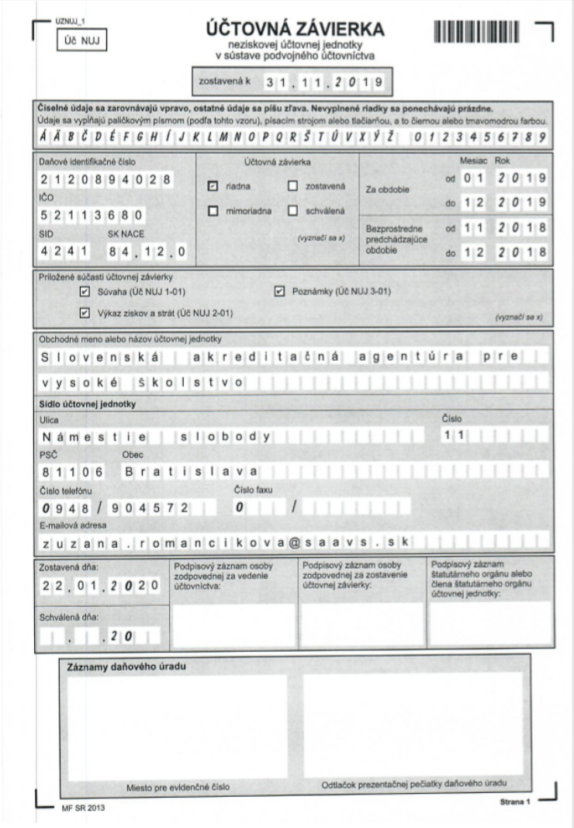

8.2. Condition and movement of property (Property Balance)

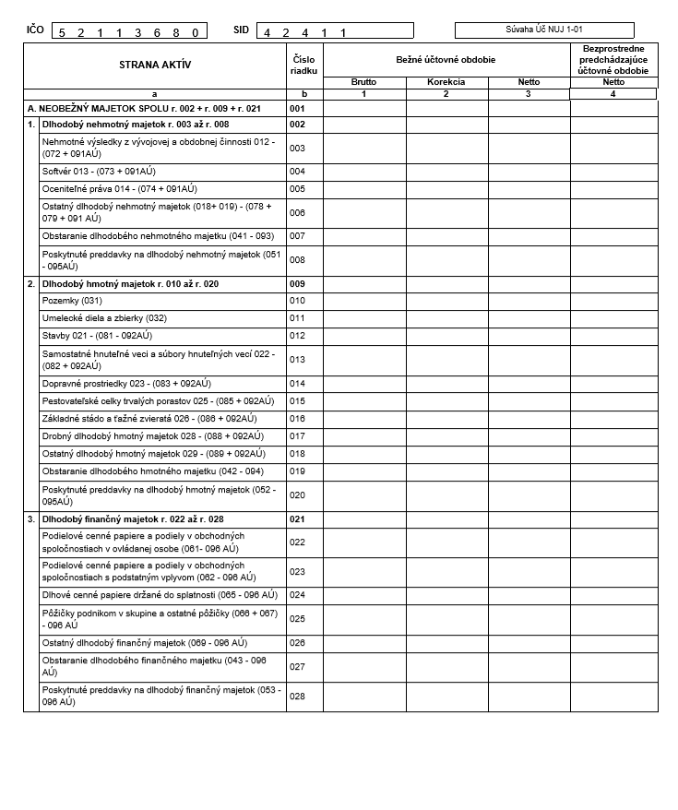

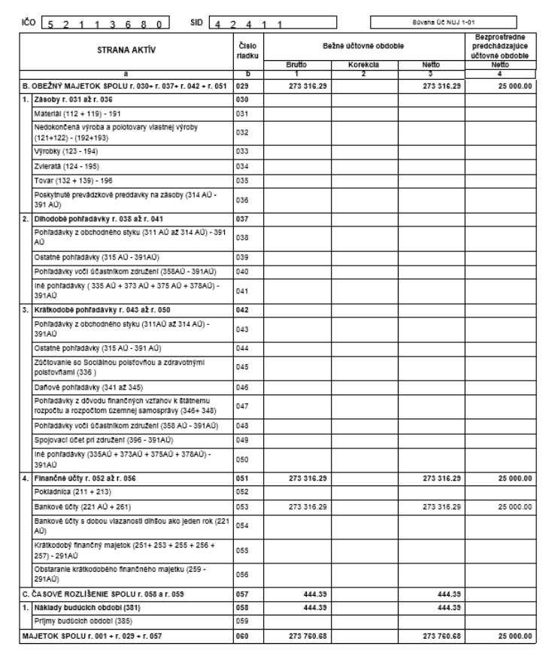

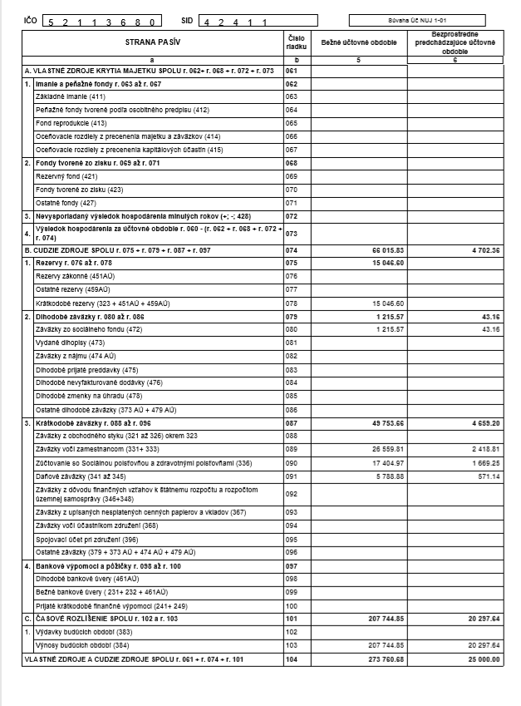

8.3. Financial flow analysis (Financial Results)

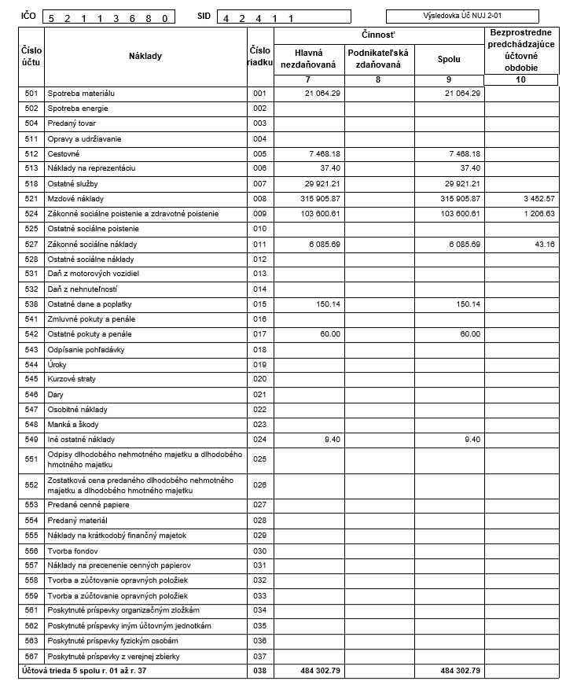

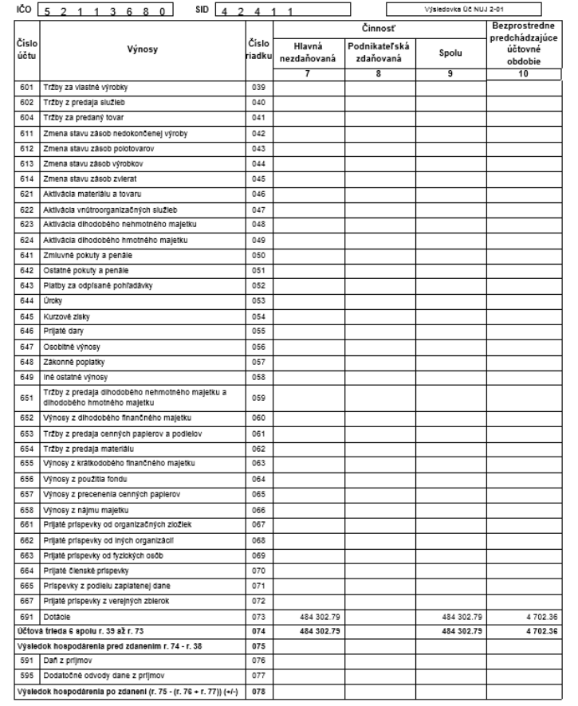

8.4. Recapitulation of clearing with the state budget

Of the total amount of funds in current expenses for € 800,000, € 625,386.42 was spent on the Agency's activities. Unspent current expenditures in the total amount of € 174,613.58 were transferred to the Ministry's account in two payments – at the end of 2019 and in March 2020 – following the contract and its addendum.

Of the capital expenditures in the total amount of € 26,750, € 6,595.08 was used. The Agency kept the balance of funds for € 20,154.92 following the contract and its amendment and following the Act on Budgetary Rules in its account, with the possibility of drawing them up by the end of 2021.

8.5. Control Activities

8.5.1. Statement of the Agency Controller
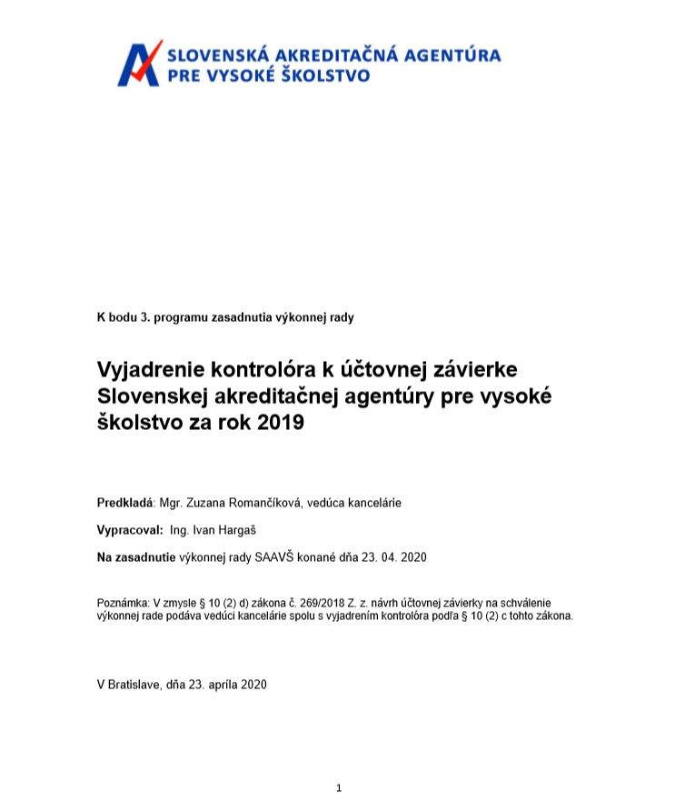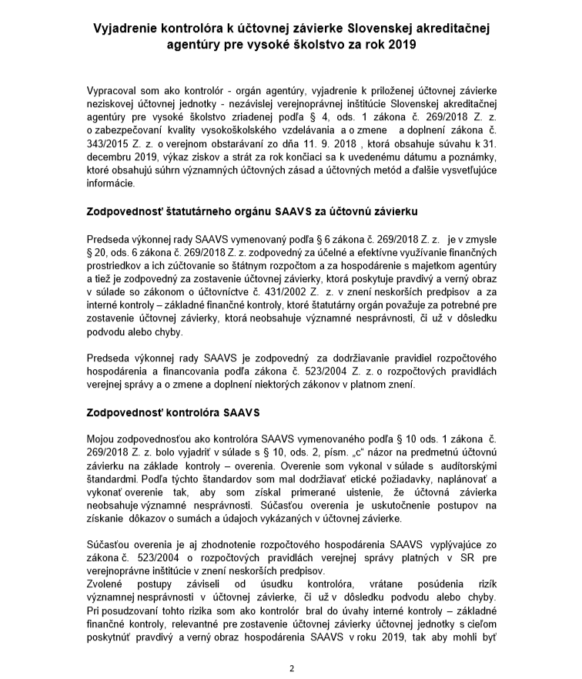

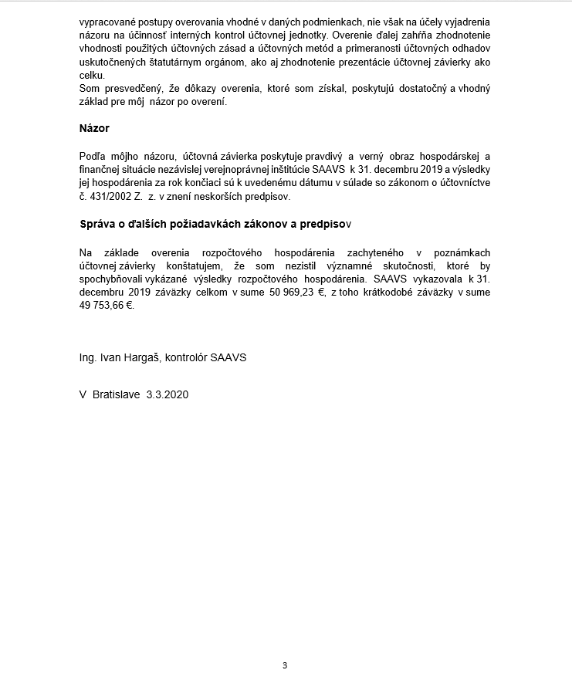

Prepared and publishes by the
Slovak Accreditation Agency for Higher Education
Námestie slobody 11
811 06 Bratislava
2019

Quality Assurance Agency
European Quality Assurance Forum

