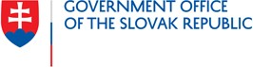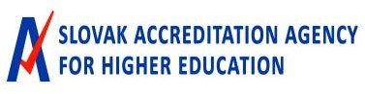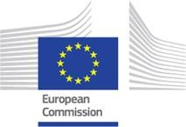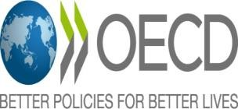

“Improving Higher Education in Slovakia” – Findings and Next Steps
Thursday 25 November, 10:00 – 11:30 CET

Context and purpose

The Institute for Strategies and Analyses of the Slovak Republic, the Slovak Accreditation Agency for Higher Education, the European Commission and the OECD are organising a virtual meeting to discuss the findings and recommendations of the project ‘’Improving Higher Education in Slovakia’’ and hear from Slovak stakeholders about initiatives they are taking to advance the quality of higher education in the country.
This project, which ran from June 2020 to October 2021, aimed to support Slovak authorities in addressing key challenges in higher education. In particular, it examined how governance and funding reforms may support the continuous improvement of higher education in Slovakia.
The project involved a series of interviews and roundtable discussions with a range of Slovak higher education stakeholders, and the regular provision of views and input by a Working Group composed of policy makers from the Ministry of Education, Science, Research and Sport, the Slovak Accreditation Agency for Higher Education, the Institute for Educational Policies, and the Research Agency.
The final report containing findings and recommendations is available on the OECD’s iLibrary in English. The “action plan” of the report is also available in Slovak.

Draft agenda

 | Draft agenda – Thursday 25 November 2021, Zoom meeting
10:00 – 10:20 | Welcome and opening remarks  - Eduard Heger, Prime Minister of the Slovak Republic (video message)  - Branislav Gröhling, Minister of Education, Science, Research and Sport of the Slovak Republic (video message)  - Robert Redhammer, Chairman of the Executive Board, Slovak Accreditation Agency for Higher Education  - Ágota Kovács, Policy Officer, Directorate-General for Structural Reform Support (DG Reform), European Commission  - Paulo Santiago, Head of the Policy Advice and Implementation Division, Directorate for Education and Skills, OECD

2 |

10:20 – 11:10  10:20 – 10:35  10:35 – 11:10 | Presentations of OECD findings and national perspectives  OECD findings  - Patricia Mangeol, Lead Analyst, Higher Education Policy, Policy Advice and Implementation Division, Directorate for Education and Skills, OECD  National perspectives  - Matej Bílik, Former Vice-President for Foreign Affairs, Student Council for Higher Education  - Prof. Pavol Sovák, Rector, Pavol Jozef Safarik University in Košice  - Renata Hall, Coordinator of the Analytical Team, Slovak Accreditation Agency for Higher Education  - Martin Kanovský, Head of Department for Strategies for Research and Higher Education Institutions, Ministry of Education, Science, Research and Sport of the Slovak Republic
11:10 – 11:30 | Q&A and concluding remarks  - Q&A with participants moderated by Paulo Santiago, Head of the Policy Advice and Implementation Division, Directorate for Education and Skills, OECD  - Veronika Rybánska, Director, Institute for Strategies and Analyses, Government Office of the Slovak Republic

