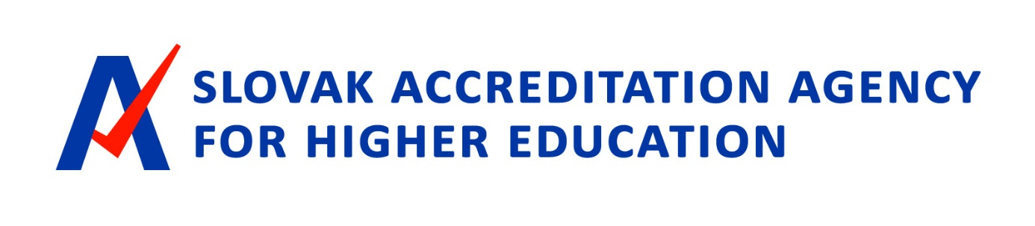

QUANTITATIVE OVERVIEWS
DEMOGRAPHIC DEVELOPMENTS
IN SLOVAK HIGHER EDUCATION FOR 1989-2020
Thematic report
From publicly available data compiled by Matej Bílik, Peter Maňo Analytical Department of SAAHE
Bratislava, 20 December 2021
SLOVAK ACCREDITATION AGENCY FOR HIGHER EDUCATION

Content
Content 2
List of charts 3
Foreword 4
Introduction 5
I. Students and graduates 9
I. a. Demographic evolution of the population of 19-year-olds 9
I. B. Developing the number of students (1989-2020) 10
I. C. Development in the number of graduates (1989-2019) 11
I.d. Development in the number of students by group of disciplines (1990/2003-2019) 12
I.e. Share of graduated population 17
II. Teachers 20
II. a. Development in the number of university teachers 20
II. B. Researchers 22
II. C. Developing the number of students at university teacher (1989-2020) 22
III. Foreign students in Slovakia 24
IlI.a. Development in the number of students with non-Slovak citizenship (2010-2020) 24
III. B. International comparison of the share of foreign students 25
III. C. Number of foreign students by group of disciplines 25
III.d. Student citizenship other than Slovak (2010-2020) 27

SLOVAK ACCREDITATION AGENCY FOR HIGHER EDUCATION

List of charts
Content 2
List of charts 3
Foreword 4
Introduction 5
I. Students and graduates 9
I. a. Demographic evolution of the population of 19-year-olds 9
I. B. Developing the number of students (1989-2020) 10
I. C. Development in the number of graduates (1989-2019) 11
I.d. Development in the number of students by group of disciplines (1990/2003-2019) 12
I.e. Share of graduated population 17
II. Teachers 20
II. a. Development in the number of university teachers 20
II. B. Researchers 22
II. C. Developing the number of students at university teacher (1989-2020) 22
III. Foreign students in Slovakia 24
IlI.a. Development in the number of students with non-Slovak citizenship (2010-2020) 24
III. B. International comparison of the share of foreign students 25
III. C. Number of foreign students by group of disciplines 25
III.d. Student citizenship other than Slovak (2010-2020) 27

SLOVAK ACCREDITATION AGENCY FOR HIGHER EDUCATION

Foreword
Dear readers,
We present one of the first thematic reports of the Slovak Accreditation Agency for Higher Education. It is devoted to basic quantitative overviews of demographic developments in Slovak higher education since the Velvet Revolution. Compilers tried to summarise the data from various publicly available sources and also to offer graphical overviews of the development of student numbers, graduates, complemented by demography of 19-year-olds and numbers of university teachers. The data are drawn mainly from data published by the Ministry of Education of Science Research and Sport of the Slovak Republic, the Centre for Scientific Technical Information of the Slovak Republic (CVTI), the former Institute of Information and Forecasting of Education (ÚIPŠ), as well as data from the Statistical Office of the Slovak Republic, Eurostat, the Organisation for Economic Cooperation and Development (OECD), INEKO, SGI and others.
The aim of this report was to concentrate in one place existing publicly available data in a comparable way and to display them graphically in order to give the reader a more illustrative idea of the “testimony” of these otherwise non-animous numbers. It is only when the number of numbers is graphically displayed that possible important connections emerge plasticly. For example, in the Slovak population there was an extreme decline in natality and thus the number of 19-year-olds by more than 40 %. This is such a fundamental and unfortunately irreversible decline that it will cause serious problems in the social and economic life of Slovakia for many years. It is also clear from the development of the number of graduates that the share of graduates has doubled. This demonstrates the fulfilment of the policies of the state “Milenium” by universities. Other interesting facts can be found in the data, so we bring them to the public for further possible use.
The present thematic report was also addressed by the Executive Board of the Agency at its 40th meeting on 16 December 2021. I would like to personally thank my colleagues for their work in compiling these reports, especially Peter Maňova and Matej Bilík.
Bratislava, 16 December 2021
Robert Redhammer
SLOVAK ACCREDITATION AGENCY FOR HIGHER EDUCATION

Introduction
The aim of the document presented is to map more than 30 years of demographic development in Slovak higher education and offers a comprehensive overview of the evolution of the monitored indicators. This document, together with future data summaries, can also serve as reference sources for further analysis. As far as possible, we used the latest available data and an adequate timeframe for the review. The overview is divided into three parts — the first is devoted to the development of the number of students and graduates in a time series. At the outset, it also offers demographic forecasts and estimates that could indicate the evolution of the number of students in the future. The second part focuses on university teachers and the evolution of their number in a time series, as well as the share of students per teacher. The final, third part looks at the development of the number of foreign students in Slovakia in 2010-2020.
The most important findings of the first part of the Scoreboard relate to the evolution of the population of 19-year-olds in Slovakia, which has been declining for a long time, although this fall is likely to stabilise in the near future. Demographic developments, among other factors (funding of HEIs, offer of study programmes, availability of study in the EU), also have a significant impact on the number of students in HEIs, which peaked in 2008, since they gradually declined to the current level. The development of the number of graduates, of course, with a slight delay, replicates the development of the number of students.
Groups of disciplines at full-time level I and II experienced the most dynamic developments, especially in the 1990s, since the situation became more stable (although, for example, the number of students in medical disciplines is gradually increasing). Part-time studies show similar trends, but social sciences, teachings and services are strongly dominated here compared to full-time studies. The same applies to external doctoral students, although the dominance of this group of disciplines is gradually diminishing. In PhD students, technical sciences and teachings and natural sciences are also significantly represented. Even in the development of the number of students in each group of disciplines, the emergence of new faculties and schools, as well as the increased interest of foreign students in certain disciplines or types of study, were the most relevant.
As regards Slovakia’s position in terms of the share of graduates in the economically active population, despite a significant shift over the last 23 years (by 16.5 %), the country continues to lag behind the OECD average as well as some surrounding countries. The situation is better for young people aged 25-34, where Slovakia has already reached the EU average.
In the second part of the factsheet, we look at the development of the number of university teachers. Over the last 10 years, there has been a gradual decline in teachers as natural persons as well as the overall total of contracts. There are relatively stable groups of professors and associate professors, while in schools mainly professional assistants are shrinking and the number of part-time teachers and non-employment teachers is increasing. Despite concerns about the slow response of HEIs in terms of optimising their staffing capacity in the context of a decrease in the number of students, higher education institutions are gradually reducing the number of teachers. However, it should be noted that the period from the end of the first decade of the 21st century was exceptional in terms of the size of the student population. This can be seen in the conversion of the number of students per teacher — the 2008 values (18-22 students per teacher) would place Slovakia at the tail of international comparisons, whether among OECD countries or the EU in terms of extremely high number of students per teacher. Currently, the number of students per teacher varies between 11.8 and 14 students, depending on the calculation methodology. Like the number of students, this ratio has stabilised as well as the number of teachers.
The findings of the third part of the Scoreboard reveal a positive trend in the number of foreign students in HEIs in Slovakia to more than 11 % of all students, which puts Slovakia above the OECD average;
SLOVAK ACCREDITATION AGENCY FOR HIGHER EDUCATION
as well as the EU22. Less positive news is that while in most OECD countries the proportion of foreign students increases with every degree of study, in Slovakia the situation is rather the opposite, leading to a significant shortage of foreign doctoral students in universities (even in comparison with surrounding countries). Another concern is related to the readiness of our universities for foreign students and their ability to meet the needs of these students — data from CVTI suggest that these students are usually not integrated and are often concentrated only in a part of the fields, thereby impoverishing their students from domestic internationalisation (i.e. the international dimension of studying at university in Slovakia). In addition, mobility within Slovakia is significantly below average compared to other countries monitored, thus reducing student experience and knowledge. Finally, the share of foreign students has recently increased mainly thanks to daily students from Ukraine, as well as students from Serbia, Germany, Hungary or Russia.
Warning
At the outset, we must draw attention to a number of data gaps that are important for their further interpretation. Published statistical yearbooks with standardised reporting (CVTI SR and formerly UIPŠ) as well as the annual reports of the Ministry of Education of the Slovak Republic on higher education begin in 2003, following the reform in 2002. Between 1989 and 2003, we only have data from time series, which are not very detailed. Moreover, following the accession of Slovakia to the Bologna Process (1998), there were changes in the structure and organisation of the studies (especially after the 2002 reform), new higher education institutions were created and the state higher education institutions separated from public universities, causing minor discrepancies in reporting. In several cases, students have been counted twice, some statistics lack students of state schools as they do not fall under the Ministry of Education of the Slovak Republic. Also in the case of reporting the number of university teachers, the published data only give us limited possibilities of interpretation, because we do not know to what extent multiple assignments increase the real number of natural persons. These statistics do not give an insight into how much time teachers spend on learning and how many other activities (research, production, administration, etc.). At the same time, we have to take into account that this is to a large extent the information reported by universities themselves in the prescribed structure and it is very difficult to verify that the data is correctly reported and whether it is valid. It is when interpreting and working with data that we often encounter limitations in the scope, quality and structure of the data. The analytical conclusions, based on these data, have the following limits. For a more in-depth and in-depth analysis, it would be necessary to verify and complement the above-mentioned data from several sources.
The available data published by the Ministryof Education of the Slovak Republic, CVTI, Statistical Office of the Slovak Republic, the Research Centre for Demographics, INEKO, OECD, and Eurostat are data of their legal owners and have been used in this review only for research and analytical purposes.
MŠVVaŠ SR (Ministry of Education, Science, Research and Sport of the Slovak Republic) “is the central government body of the Slovak Republic for kindergartens, primary schools, secondary schools and universities, school facilities, lifelong learning, science and technology, for state care for youth and sport” Statute and Organising Regulations of the Ministry of Education, Science, Research and Sport of the Slovak Republic (minedu.sk).
CVTI (Centre of Scientific and Technical Information) is "as a directly managed organisation of the Ministry of Education of the Slovak Republic, the National Information Centre for Science, Technology, Innovation and Education and the Scientific Library of the Slovak Republic. Coordinates and ensures the operation of interdisciplinary research
NO
SLOVAK ACCREDITATION AGENCY FOR HIGHER EDUCATION
development centres and national infrastructures for research, development, innovation and education" (Basic Information — CVTI SR).
The Statistical Office of the Slovak Republic is the "central government body of the Slovak Republic in the field of state statistics. Its status is governed by Act No 575/2001 on the organisation of government activities and the organisation of central state administration, as amended. The Office performs tasks pursuant to Act No 540/2001 on State Statistics, as amended, and tasks laid down by other generally binding legislation. The Statistical Office of the Slovak Republic has been operating as a separate institution since 1 January 1993, the date of establishment of a separate Slovak Republic" (Statistical Office of the Slovak Republic (statistics.sk).
The Demographic Research Centre "was founded 1. 1. 2000. Works within INFOSTAT (Institute of Informatics and Statistics)". It has been set up as a specialised research centre of a sub-industry nature with national competence.
INEKO is a “non-governmental non-profit organisation that supports economic and social reforms in order to remove obstacles to the long-term positive development of the Slovak economy and society” (INEKO: About us).
“The Organisation for Economic Co-operation and Development (OECD) is an international organisation that works to build better policies for better lives. Our goal is to shape policies that foster prosperity, equality, opportunity and well-being for all. We draw on 60 years of experience and insights to better prepare the world of tomorrow" (About the OECD — OECD).
Eurostat is the statistical office of the European Union (Who we are — Eurostat (europa.eu).
SLOVAK ACCREDITATION AGENCY FOR HIGHER EDUCATION
- Students and graduates
- a. Demographic evolution of the population of 19-year-olds
Population grades of nineteen year olds represent the abundance of young people in the population around the age of graduates, i.e. at the age of secondary school graduates entering employment or applying for the first level of higher education. The picture (Figure 1) does not take into account the share of this cohort studying abroad.
The last available figure for the population of 19-year-olds in Slovakia is from 2020 (54 977) and shows a decrease of 43.2 % compared to the period with the maximum number of people in this cohort (96801) in 1998. We can expect an even deeper fall in the coming years, which should stop just over 50 thousand (2020-2022). An increase is expected in the second half of the 20's and the number of 19-year-olds should again exceed 60 thousand. However, this should only be a short-term increase. According to our calculations, the number of 19-year-olds should fall again in the 1930s. However, our calculations are only approximate estimates based on the number of births and reflect a static mortality rate of only 2 deaths per 1000 people, based on the mortality of people under 19 in Slovakia in 2020. They do not reflect the consequences of the migration of parents with children to or from Slovakia (the figure being high) or possible other factors that take into account demographics in similar forecasts (e.g. the covid-19 pandemic). For this reason, we do not recommend publicly using estimates since 2031 above.
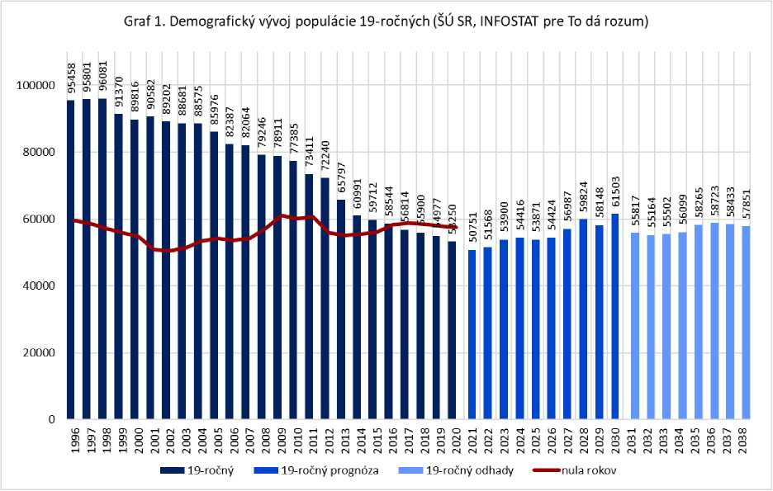
Graph 1. Demographic development of 19-year-olds and born in Slovakia, forecasts and estimates

The development of the number of born and 19-year-olds comes from data from the Statistical Office of the Slovak Republic until 2020. Between 2021 and 2030, a forecast of the evolution of the 19-year-old cohort since the Research
SLOVAK ACCREDITATION AGENCY FOR HIGHER EDUCATION
the Demographic Centre at INFOSTAT, which was designed for the needs of the project “This will make sense”. For 2031-2038, this is only our own estimate based on the number of births in 2012-2019 and static mortality.
Based on the demographic assumptions of the INFOSTAT Demographic Research Centre for the project, we can expect a slight increase in the population of 19-year-olds in the next decade, which should reach the 2014 level by 2030. However, the increase is not evenly distributed regionally, due to population migration within Slovakia and the development of natalities in western Slovakia. The largest population increase in the 19-year-old cohort between 2018 and 2030 should come mainly in the Bratislava region (up to 84 %) and then in Trnava region (by 17 %), while the other four regions of Slovakia will retain approximately the same number (TN + 7 %, NR + 2 %, ZA 0 %, KE 0 %) and in two cases the cohort will even decrease (PO -2 %, BB -4 %).
- B. Developing the number of students (1989-2020)
Since the fall of communism, the number of students gradually increased until 2008, when it reached its peak, when more than 230 thousand students studied in Slovakia (Figure 2). In addition to favourable demographic developments, the increase was linked to the emergence and expansion of several public HEIs in the 1990s and early 21st century. This was because Slovakia lagged significantly behind developed countries in the share of the HE population (in 1998 only 10.3 % of the active population aged 25 —
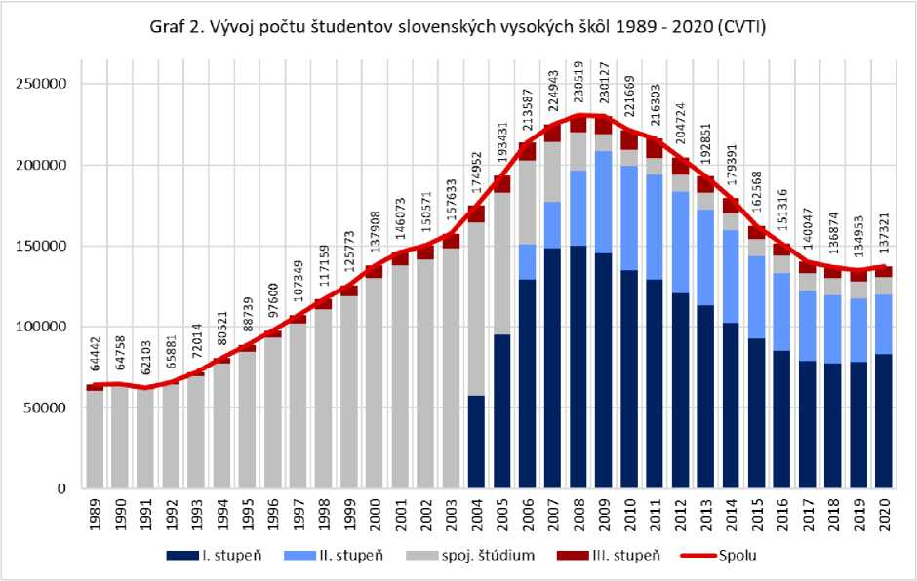
Figure 2. Development of the number of students in Slovak universities
SLOVAK ACCREDITATION AGENCY FOR HIGHER EDUCATION
64 had higher education, OECD average was 20 %, France 21 %, Germany 23 %, UK 24 % and the United States even 35 %). Private schools were mainly established between 2002 and 2006, outside of this period the University of Management — City University in Trenčín (1999) and HUAJA in Banská Štiavnica (2011). Since the late 1990s, the development of HEIs has also been driven by a funding system that tied subsidies primarily to the number of students. At the same time, as a result of joining the EU, several professions have started to require higher education (e.g. for nurses). Nevertheless, Slovakia has long been lagging behind from neighbouring European countries and the OECD average in the share of HE of educated and economically active population (Figure 12), although it has already reached the EU average for the younger generation (26-34 years) (Figure 13).
The decline in the number of students has stabilised since 2017 and has reached approximately the 2000 level. There was even a slight increase in 2020 (2368 students) compared to 2019, possibly partly due to the COVID-19 pandemic, which could deter part of students from studying abroad. There has also been an increase in the population of foreign students, which increased by up to 1200 students compared to 2019. We do not have data to explain this increase and it is not clear what we can attribute to it.
The figures in Figures 2 and 3 have some shortcomings which may partly distort developments. As part of the implementation of the Bologna Process in 2002, Act No 131/2002 on higher education institutions Z. z., there was a mandatory division of studies to I. and II. degree, while only a few study programmes remained connected. In the following years (2003-2006), some students (as well as graduates) were counted twice. Until 2004 we only have data available together for all programmes (together I and II degrees as well as combined studies), only doctoral programmes were excluded. In 2005, students of the 1st degree were already mentioned separately, the complete division into three degrees and the combined study in statistics only came in 2006.
- C. Development in the number of graduates (1989-2019)
Graduate statistics are always updated towards the end of the calendar year, so statistics for 2020 were not yet available at the time of writing of this report (November 2021). In 2019, the number of graduates reached a similar level as in 2006 (Figure 3). More than 38 thousand students completed their studies in that year, of which the students of the second degree and the combined studies consisted of 18 525 graduates, students of the I. degree 17 379 and PhD students 1404. Compared to 2018, the decrease was mainly for bachelor graduates. We can expect the abundance of graduates to stabilise in 2020-2023, as the development of the number of graduates logically with a slight ‘delay’ replicates the development of the number of students.
In a time series, we can see that higher numbers of students as well as graduates in the second half of the first decade of the 21st century were mainly due to Bachelor students. It was their number that changed most during this period. Unfortunately, before 2004, we do not have data on the number of graduates in each degree due to a change in the structure of the study. It should be noted that the breakdown by grade does not always include all graduates, as state schools do not fall under the Ministry of Education
NO
SLOVAK ACCREDITATION AGENCY FOR HIGHER EDUCATION
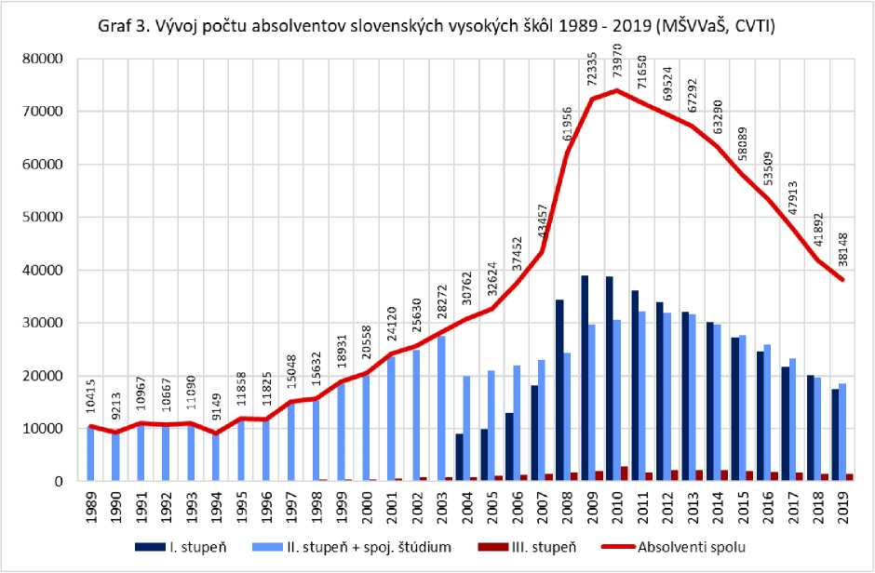
Figure 3. Development of the number of graduates of Slovak universities

— in this case, statistics from the annual reports are combined, which include graduate numbers by grade, but only for public and private higher education institutions. However, in the total number of graduates there are also graduates from state higher education institutions.

I.d. Development in the number of students by group of disciplines (1990/2003-2019)
The trend in the number of students by group of disciplines shows a number of significant trends over the last 18 (absolute numbers) and 31 years respectively (percentage). For I+II students, the number of students in social sciences, teaching and services culminating in 2009 (daily) and 2008 (external) respectively, with a gradual decline to the current level (Figures 4.5). This development was more dramatic among external students, whose number almost doubled at some point in 2008 in the reporting period. However, it is highly likely that the increase in this group of disciplines was largely due to an increase in the number of students in teaching, teaching, economic and managerial disciplines or in social work — during the period under review, the offer of study in the fields mentioned above increased considerably (by the emergence of new programmes, faculties as well as higher education).
SLOVAK ACCREDITATION AGENCY FOR HIGHER EDUCATION
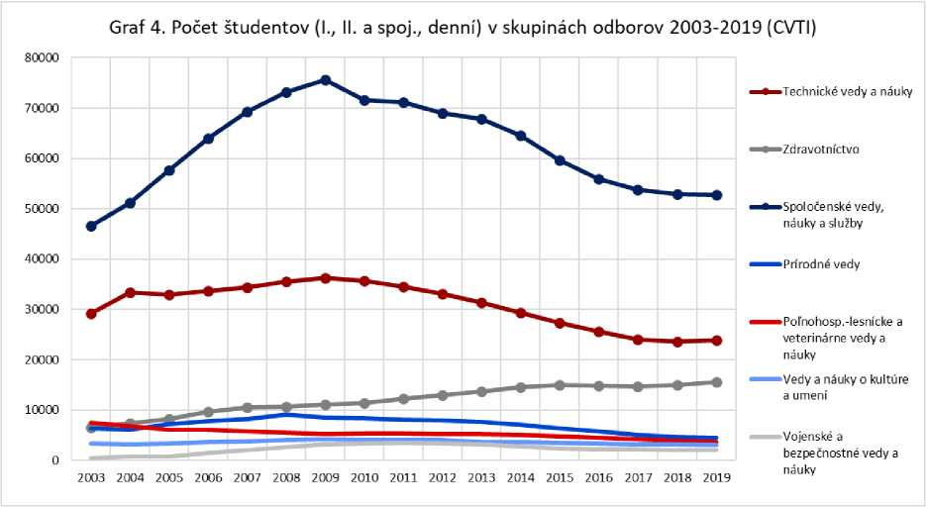
Figure 4. Development of the number of full-time students of I + II level by groups of disciplines

Figure 5. Number of students (L, II. and liaison, external) in groups of disciplines 2003-2019 (CVTI)
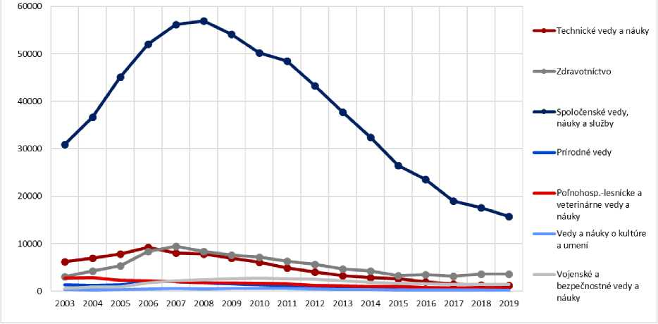

Figure 5. Evolution of the number of external students I. + II. degree by groups of disciplines
However, looking at Figures 6 and 7, it can be seen that this increase was not at the expense of other groups of disciplines over the period under review, as the proportion of students in social sciences, teaching and services has remained at around 50 % (daily) and around 70 % (external) of the total number of university students since the middle of the first decade of the 21st century.
SLOVAK ACCREDITATION AGENCY FOR HIGHER EDUCATION
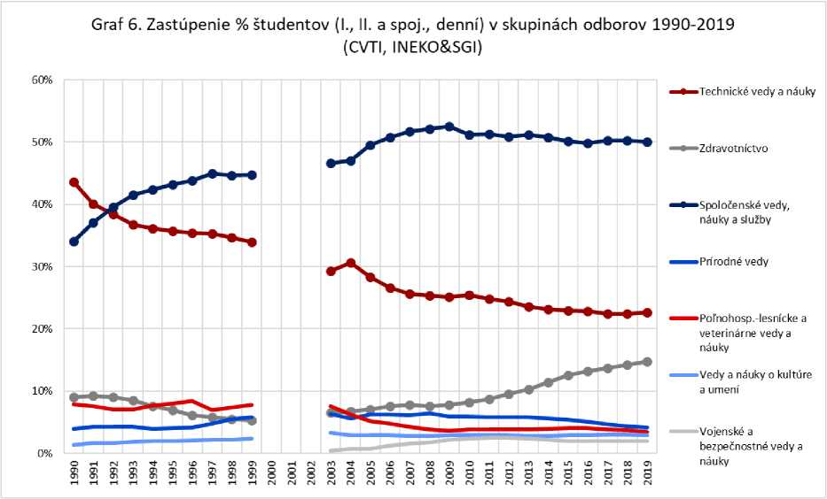
Figure 6. Evolution of the percentage of full-time students of I + II level by groups of disciplines¹⁰

However, a deeper look into the past reveals that their share grew the most in the 1990s. Between 1990 and 1999, the proportion of these students increased by 10 percentage points (Figure 6) in full-time studies and by more than 20 percentage points (Figure 7) in external studies. In 1992, this group of trade unions at the first
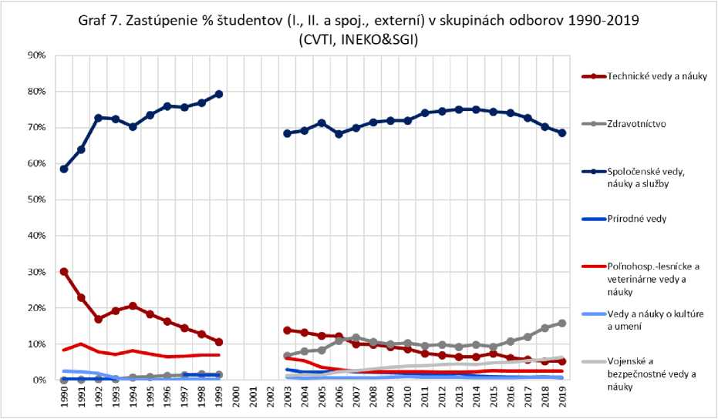
Figure 7. Development of % share of external students I+II by groups of disciplines¹¹

- For the period 1999-2003, the required data were not available.
- For the period 1999-2003, the required data were not available
SLOVAK ACCREDITATION AGENCY FOR HIGHER EDUCATION
the site was replaced by technical sciences and doctrines that previously dominated. It is worth noting the long-term growth of the health sector group, in which the number of daily students over the period 2003-2019 (Figure 6) has more than doubled, with the share of study subjects rising to almost 15 % (daily students) and close to 16 % (external students). In this case, the development of the Nursing Department as well as the growing popularity of medical disciplines among foreign students (Figure 19), e.g. from Greece or Norway, probably contributed to the development described above.
The evolution between the groups of disciplines in grade III students reflects the situation described above only to a certain extent, with its specificities. Overall, it can be assessed that while external doctoral candidates tended to decline gradually over the reporting period (Figure 9), the number of full-time doctoral candidates first increased and then declined above or to their 2003 baseline level across groups of disciplines (Figure 8). One of the likely causes of such development was the financing of universities, since it was originally also linked to the number of PhD students. It was only later that the money for PhD studies became part of the science package.
Social sciences, teachings and services are more prominently dominated by external students (Figure 9), where they hold relatively clear leadership for a long time (although this trend has gradually weakened in recent years — their most significant advance in 2008 was about three times that of today). On the contrary, external doctoral students of the health sector group recorded a more significant increase as the only ones in the last survey year (2019), but it is questionable whether this is a new trend or just a return to status before 2018.
Figure 8. Number of students (IIIth degree, full- time) in groups of disciplines 2003-2019 (CVTI)
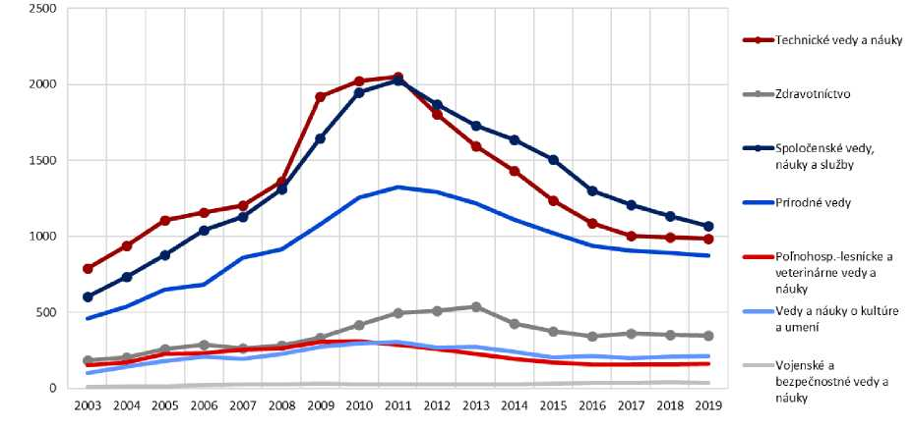
Figure 8. Evolution of the number of full-time students of grade III by groups of disciplines

For full-time students (Figure 8), the situation differs, with three groups of disciplines — technical sciences and teachings, social sciences, teachings and services and natural sciences more strongly dominated over the period under review (with weaker growth compared to the remaining two in 2007-2009). The remaining groups of trade unions hold a relatively stable population of their students, with a small exception of medical disciplines:
SLOVAK ACCREDITATION AGENCY FOR HIGHER EDUCATION
medical disciplines increased more strongly in the middle of the reporting period, but subsequently approached the remaining three groups of disciplines with fewer students compared to the leading trio described above.
Figure 9. Number of students (IIIth degree, external) in groups of disciplines 2003-2019 (CVTI)
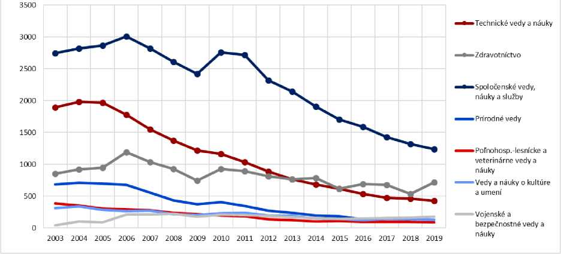
Figure 9. Evolution of the number of external students of Grade III by groups of disciplines

The view of the relative representation of trade union groups again illustrates the overall picture and slightly corrects the interpretation offered above. While the same three groups of disciplines still dominate the share of their daily doctoral students, this share did not change significantly over the period under review, although again some shifts occurred (Figure 10). While technical sciences and teachings declined by 5 percentage points compared to the beginning of the reporting period, thus losing a leading position, social sciences, teachings
Figure 10. % Of students (level III, full-time) in union groups 2003-2019
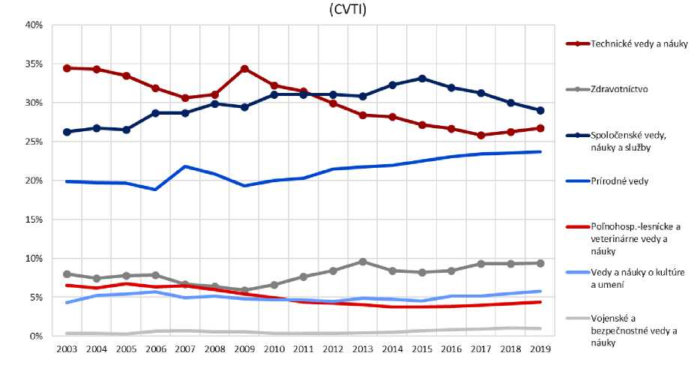
Figure 10. Evolution of the percentage of full-time students of grade III by group of disciplines
SLOVAK ACCREDITATION AGENCY FOR HIGHER EDUCATION
and the services improved by almost 3 percentage points and gained leadership. Similarly, natural sciences grew by almost 4 percentage points towards the end of the reporting period and withdrew their loss to leading groups of disciplines. The remaining groups of trade unions developed relatively constant and, after a slight decline in the middle of the period under review, with the exception of agro-forestry and veterinary sciences, and teaching came slightly above their baseline.
External doctoral students (Figure 11) are again more strongly dominated by social sciences, teachings and services, which, with the exception of the last three years under review, have increased the share of their students in the overall population. In technical sciences and teachings, we see a gradual fall to less than 15 % from the original over 27 %, on the contrary, in the period under review, the proportion of external doctoral students increased by 100 % from the original 12.3 % to 26.6 % in 2019. The share of the remaining trade union groups did not change significantly for this group as a whole, although the different groups of trade unions gradually approached the mid-point (their deviations declined), while in 2006 the differences between them were almost negligible. After this year, their respective shares again began to vary very slightly, with their ranking almost turning mirror — e.g. military and security sciences and doctrines recorded the most significant increase (almost 9 times) and moved from last to first position, on the contrary, natural sciences recorded the largest decline (by more than half in 2006) and lost leadership.
Figure 11. % Of students (Grade III, external) in union groups 2003 -2019
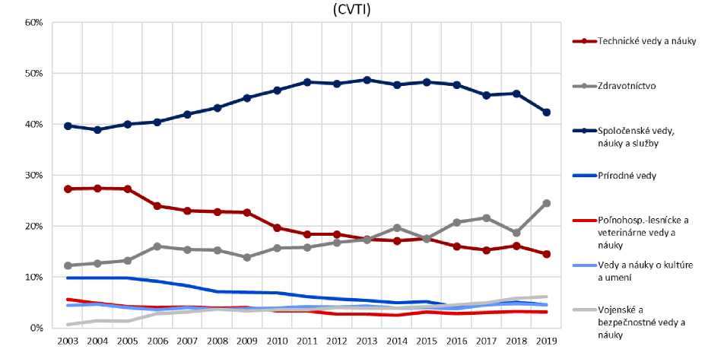
Figure 11. Evolution of % share of external students of Grade III by groups of disciplines

I.e. Share of graduated population
Due to limitations in the reporting of graduates, tracking the evolution of the share of the population with higher education is one of the other options for observing the development of higher education. Figure 12 shows the share in the entire active population (24-64 years), while Figure 13 only looks at young people aged 25-34. These images do not show the degree of education obtained, but make it possible to compare the level of education across countries. By comparison, the graph shows the surrounding countries as well as the average of the countries associated in the OECD (Figure 12) and the average of the 27 EU countries (Figure 13).
SLOVAK ACCREDITATION AGENCY FOR HIGHER EDUCATION
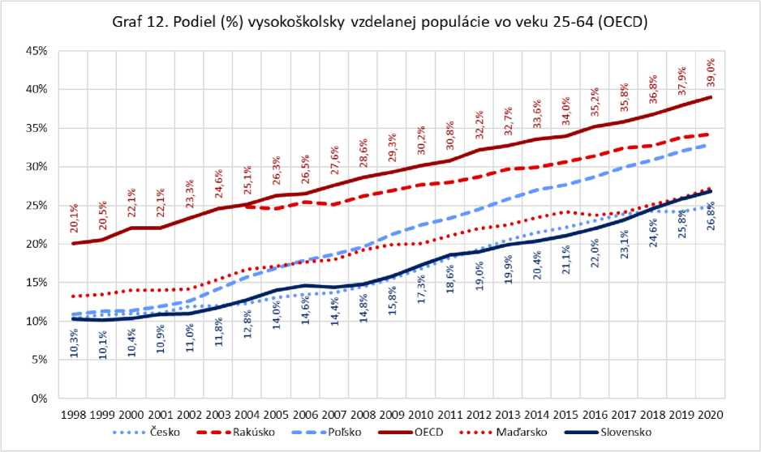

Figure 12. Share of active population 25-64 years with higher education
Over the past 23 years, Slovakia has managed to increase the share of graduated people in the economically active population by up to 16.5 percentage points (Graph 12). However, all surrounding countries follow a similar trajectory. Thus, Slovakia despite mass access to university
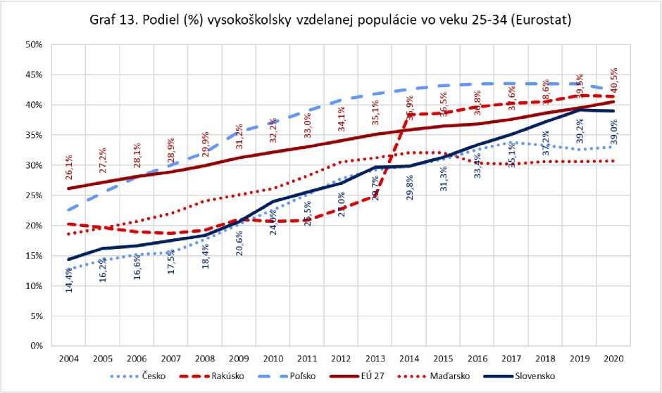
Figure 13. Share of population 25-34 years with higher education
SLOVAK ACCREDITATION AGENCY FOR HIGHER EDUCATION
education remains below the OECD average. The Hungarian and Czech economically active populations have a similarly high share of HEIs educated as Slovakia, while Poland and Austria are ahead of 7 and 8 percentage points respectively. The educational gap of the entire population surveyed is partly due to the lower level of education of older generations.
A similar increase in education levels can be seen in the view of the population of young people aged 25-34 (Figure 13). The Eurostat comparison further reflects the rise in higher education since the 1990s and is more closely linked to demographic developments in recent years. Slovakia reached almost the EU average and has a stronger lead over Hungary and the Czech Republic. In the case of surrounding countries, we have seen the stabilisation of the share in the last 3-5 years, while Slovakia has risen sharply, the question is whether Slovakia started its stagnation in 2019.
SLOVAK ACCREDITATION AGENCY FOR HIGHER EDUCATION
- Teachers
Higher education teachers make up a relatively diverse group of university staff, taking into account their positions and functional positions, as well as the size of their assignments and the proportion of time spent on research or creation, administration or support services. As for students, the number of teachers is reported as at 31 October. Teacher conversions can be done on the basis of the number of natural persons (FO) or on a contract basis (FTE).
- a. Development in the number of university teachers
The overview of the evolution of the number of teachers is divided into the number of teachers as natural persons — FO (Figure 14) and as a full-time equivalent — FTE (Figure 15). Since the data in these cases come from two different sources, the categories differ slightly. In the case of FO, the source of the data is the regular statistical reporting of higher education institutions for CVTI, which is carried out on 31 October each year. Persons whose time includes pedagogical activities are divided into full-time and part-time employees. Full-time employees shall have at least 2/3 of the time, the individual positions and functions shall be reported separately in this case: Professor, Associate Professor, Assistant and others (assistant, lecturer, visiting professor). Part-time teachers have less than 2/3 of the time and are reported together regardless of their position or function. All teachers are reported as natural persons, so the size of their assignment is only taken into account in the division into full-time and part-time teachers. Researchers in these
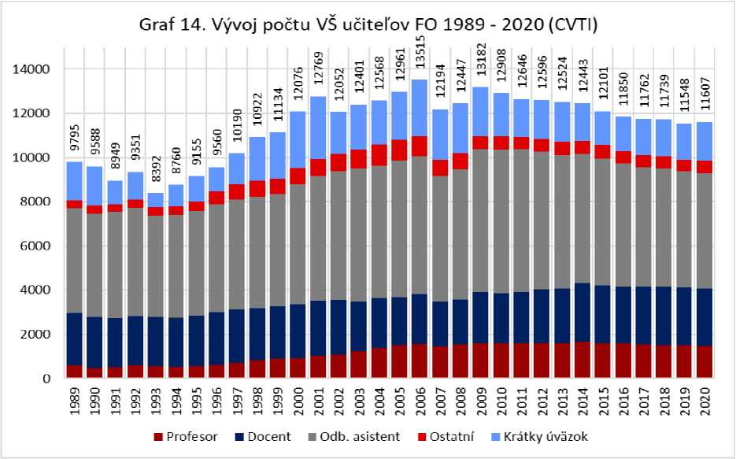
Figure 14. Development of the number of university teachers FO 1989-202O¹⁷
SLOVAK ACCREDITATION AGENCY FOR HIGHER EDUCATION
statistics are not separated and appear to be counted, even if only part of their work is linked to educational activity. It is therefore not clear whether a part-time teacher teaches one or more subjects and how much time he actually devotes to students versus other activities — that is to say, in what proportion is to be included in the conversion of students into a teacher.
The evolution of the number of teachers by position differs from that of the number of students, as teachers remain longer in higher education (mostly the whole career), which is reflected in the greater stability of the indicators on the chart over the years shown. In 2020, the number of teachers was between 1999 and 2000. The number of professors has declined very slightly in recent years, associate professors are a relatively stable group. In terms of changes in staff structure, the most moving groups are assistants and short-term teachers. The numbers of teachers in other positions have stabilised since 2010. There was a leap between 2006 and 2007 which is likely to result from a change in reporting. It is also unclear from the available sources whether the same person can be counted several times. According to the HEI register, persons with multiple contracts are slightly over 400, their average time is 1.36. These contracts may slightly overestimate the real number of individuals active in higher education institutions. In the last decade, however, there has also been a decrease in multiple contracts.
Figure 15 shows the number of teachers, expressed in full-time terms, i.e. the sum of the contracts rather than the number of persons performing these contracts. This data comes from the public section of the Register of Employees of Higher Education. The register is updated by universities on a monthly basis, with a total of 11 functions/positions to which staff can be assigned. Only the categories relevant to the learning activity were used for the display: [1] together Professor and Professor, [2] Associate Professor, [3] Assistant, [4] Assistant, [5] Lecturer and [6] Staff engaged in non-employment activities of the University of Teacher.
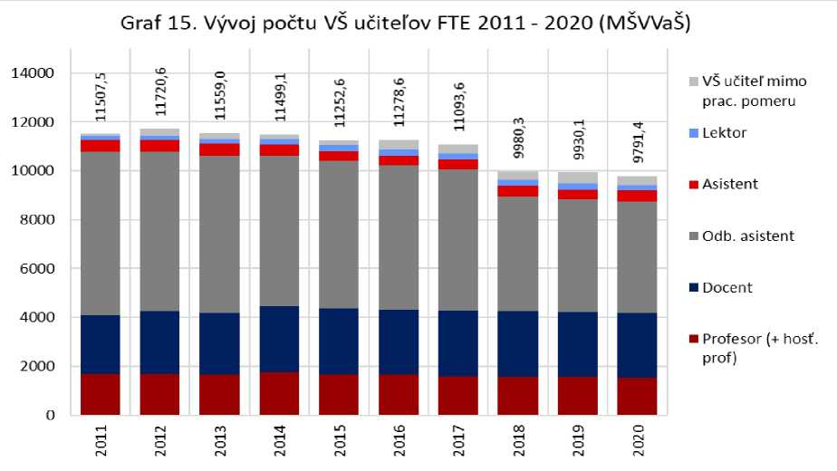
Figure 15. Evolution of the number of university teachers FTE 2011-2020¹⁹
SLOVAK ACCREDITATION AGENCY FOR HIGHER EDUCATION
While natural persons fell between 2011 and 2020 to 92 % of the 2011 stock, the contraction was more pronounced and fell to 85 % of 2011. The biggest decrease was in the group of assistants, where almost 30 % of staff left in the last 10 years. At the same time, there was an increase in teachers working alongside other professional activities. There is also a significant difference in the total number of teachers — while the physical persons employed as many as 11.6 thousand people in HEI, according to full-time equivalents, they accounted for only 9.8 thousand full-time jobs.
- B. Researchers
In addition to teachers, there are also researchers in higher education. Detailed data on their operations have been available since 2011 on the basis of a public overview of the Register of Employees. Currently, 1520 full-time equivalents (FTEs) are employed in higher education institutions in a research-related position. Of these, researchers make up more than 1481 contracts. Technicians, auxiliaries and staff engaged in non-employment research activities shall have a total of less than 39 jobs. Since 2011, there has been a significant decrease of more than 200 jobs, the number of technicians has almost halved from 39 to 21.
- C. Developing the number of students at university teacher (1989-2020)
More important data than teacher numbers is the conversion of students into teachers. Figure 16 shows the number of students per teacher and reflects different calculations of the number of university teachers. Student data are always reported on 31 October of a given year and come from data published by CVTI. The number of teachers was with one exception (FTE in 2011 was 31. 12. 2011) also quoted on 31 October. The graph shows three different variants of the calculation, the grey line contains the basic conversion based on the number
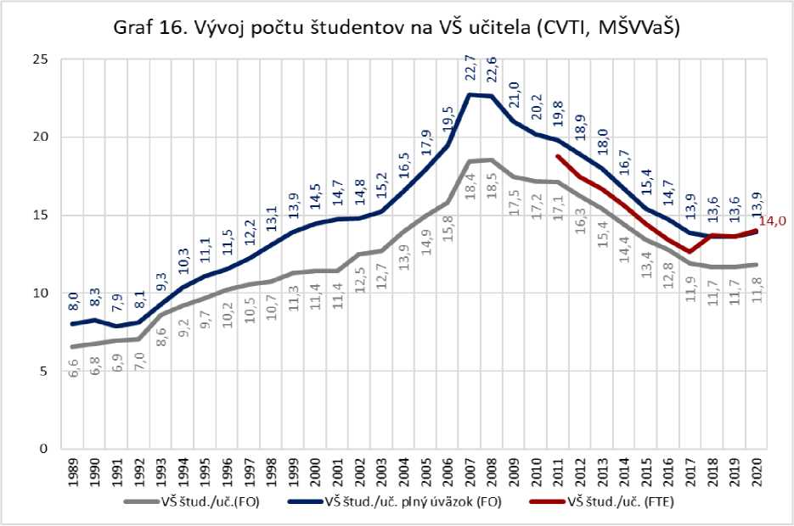
Figure 1616. Development of the number of students per university teacher
SLOVAK ACCREDITATION AGENCY FOR HIGHER EDUCATION
teachers like FO, regardless of whether they are full-time or part-time teachers. The limitation is that all teachers, including those with incomplete contracts, are counted as full-time teachers. The blue line shows only the conversion with full-time teachers, i.e. if they have more than 2/3 of the time. Thus, more than one-tenth of part-time persons are omitted from the calculation. The red line shows a full-time equivalent (FTE) conversion, but source data only exists since 2011 and only takes into account contract sizes (not real persons).
Thanks to different calculation approaches, we have the opportunity to compare the consequences of different data sources on the resulting set. The conversion of the number of students per teacher follows the development of the number of students, with a sharp increase from the 90s until the end of the first decade of the 21st century, followed by a gradual decline since 2009 and stabilisation in the last 3 years. If we look at a case where all teachers, including part-time teachers, are engaged in teaching, there were 11.8 students per teacher in 2020. If we do not take part-time teachers into account, there were as many as 13.9 students per teacher. If we only look at full-time equivalents, this number will rise to 14 students per teacher. These figures are approximately at the 1999-2001 level.
In recent years, a number of analyses have focused on the slow decline of teachers compared to the trend in student numbers. However, their calculations have focused on developments only in the last 10-15 years. However, if we look at these data in a larger time window, we will find that the current state of affairs resembles a situation from the turn of the millennium. Slovakia ranks 4th in the international comparison of the OECD, with a value of 11.4 students per teacher, but older data (reported in 2019 but reflecting the situation in 2018) that do not take into account the size of the contracts. The data are jointly collected by UNESCO, OECD and Eurostat. The last published year was 2019, based on the number of students 137 thousand and the number of university teachers of 11.6 thousand, approximately corresponding to the 2018 values. However, the source data does not correspond to the statistics published by CVTI.
SLOVAK ACCREDITATION AGENCY FOR HIGHER EDUCATION
- Foreign students in Slovakia

IlI.a. Development in the number of students with non-Slovak citizenship (2010-2020)
In recent years, we can see an increase in both the number and proportion of students who have non-Slovak citizenship (Figure 17). While in 2010 these students accounted for just about 4 % of all students, which was just over 9 thousand students, in 2020 it was already over 11 %, representing 15 432 people. Importantly, their preferred form of study is also changing — there has been a significant increase in the number of students, especially in full-time form.
It should be stressed that when studying externally, the impact of foreign students on school and students is very limited. Schools use external students as a source of additional income rather than facilitating so-called internationalisation at home, which has positive effects on domestic students, such as the possibility to improve in another language or learn to cooperate with people from other cultures. Foreign students are also a promise of a future skilled workforce for Slovakia, but in this respect, immigration and integration policies need to be improved, both at state level and at HEI level. Interestingly, the pandemic and the associated quarantine measures have not yet had a significant impact on the growth in the number of foreign students. This would require further analysis.
Figure 17. Evolution of the number of students with non-SK citizenship (CVTI)
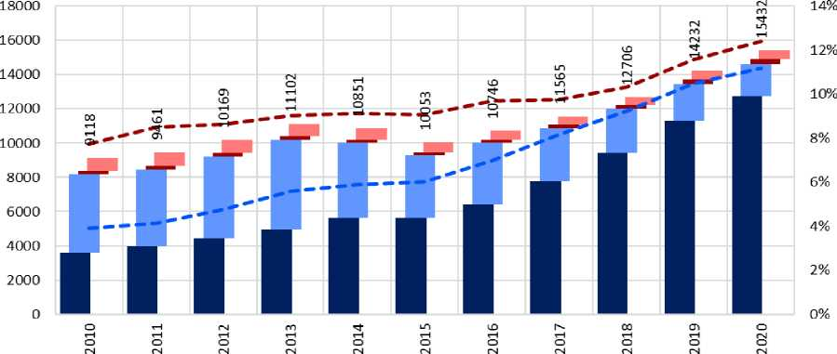
III. degree — study with a non-SK citizen. (external) III. degree— study with a non-SK citizen. (full days)
L+ll degree, joint. — study with a non-SK citizen. (external) L+ll degree, joint. — study with a non-SK citizen. (full days)
— —share (%) study with non- SK citizen. — L+ll degree, joint. — —share (%) study with non - SK citizen. — Stage III

Figure 1717. Development of the number of students with non-Slovak citizenship at universities
When analysing the development of the number of foreign students, it is important to distinguish between different degrees of study. From the beginning of the time series, for example, see a more significant share of foreign students in external compared to full-time doctoral studies, although it is gradually shrinking. In recent years, there has also been a rapid increase in daily foreign students of I. and II degrees at Slovak universities at the expense of externalists.
SLOVAK ACCREDITATION AGENCY FOR HIGHER EDUCATION
- B. International comparison of the share of foreign students
In the international comparison, Slovakia’s aggregate representation of foreign students is above the OECD average, even the EU2 2. Figure 18 is taken from Education at Glance 2021, which published an overview of the representation of foreign students by grade of study based on data from 2019. The comparison also shows that Slovakia is already above the OECD and EU average for the 1st degree and the total population of foreign students22. There is a significant shortage of foreign students in doctoral studies, where the OECD averages 20 %, which is almost 12 percentage points higher than in Slovakia.
Several states of the former Eastern Bloc, including Slovakia, have a shortage of foreign students at II and especially III degrees. In Western countries, there is a clear trend where, as the degree of study increases, the proportion of foreign students increases, which can be seen in the plotted trend line of the proportion of foreign doctoral students. This reflects higher mobility within university studies abroad, while in Slovakia there is a tendency to stay in one university from a bachelor to a doctorate. However, Slovakia is also lagging behind compared to neighbouring countries — Hungary, Austria, but also Czechia are able to attract more foreign students — Slovak universities therefore have strong competition across borders.
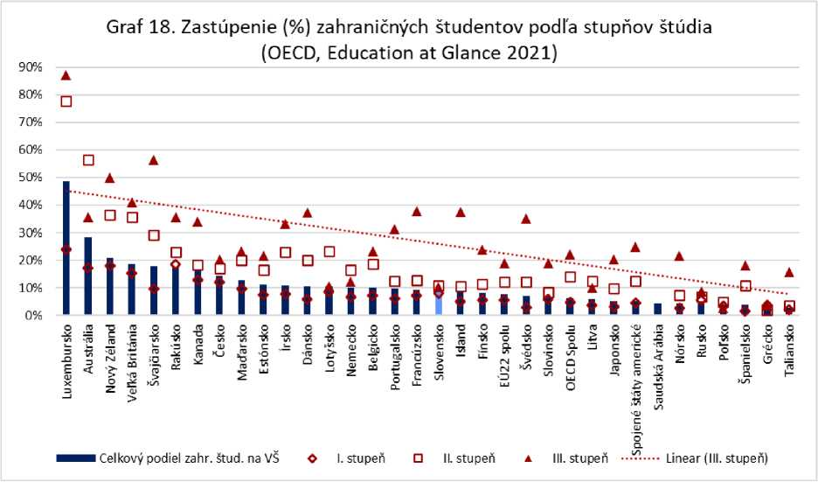
Graph 1818. Representation of foreign students at different levels of study

- C. Number of foreign students by group of disciplines
Although we could say that at least in the total share of foreign students Slovakia does not lie behind Europe and OECD countries, the overall picture is somewhat different. At I and II levels, the problem is that students concentrate only in certain disciplines (medicine, veterina, pharmacy) and, in addition, they are often separated from Slovak students who are so deprived of the dimension of internationalisation when teaching
SLOVAK ACCREDITATION AGENCY FOR HIGHER EDUCATION
study. In 2019, the number of foreign students (I., II. and combined studies) in health and social sciences, teaching and services was equalised. The increase in social sciences, teachings and services in the last 3 years was the largest share of students with Ukrainian citizenship, who are also more likely to enter Slovak programmes. Survey data from the Academic quarter-hour suggest that foreign (especially Ukrainian) students attend Slovak programs, although according to their own statements they do not know well in Slovak. The question therefore arises as to the quality of this education and whether these students are for some HEIs only a means of replacing the subsidy for shrinking Slovak students, since in the case of teaching in Slovak HEIs they receive a state subsidy (pursuant to Section 89(4) of the Higher Education Act 131/2002 Coll.).
Figure 19. Development of the number of students with non -SK citizenship L,II. degree and connection, studying the floors of groups of disciplines (CVTI)
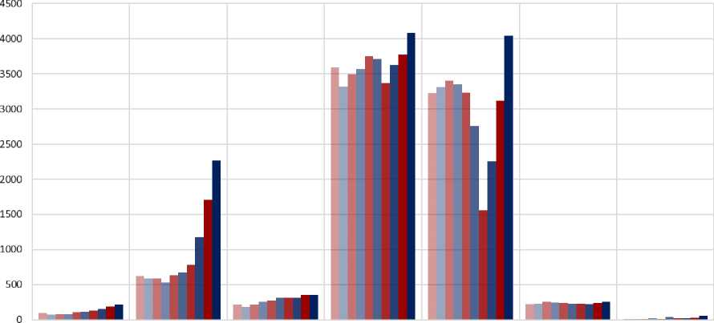

Natural Sciences | Technical sciences and | Poľnohosp.-forestry and | Health | Social sciences; | Sciences and teachings about | Military and
 | teachings | veterinary sciences and |  | teachings and services | culture and Arts | security sciences and
 |  | teachings |  |  |  | teachings
2010 2011 2012
2013 B2014 12015 12016 12017 12018 12019

Figure 1919. Evolution of the number of students with non-SK citizenship by groups of disciplines

III.d. Student citizenship other than Slovak (2010-2020)
In 2019 (Figure 20), for the first time among foreign students, Ukraine was the largest group of students, which appears to be a longer-term trend, as the number has increased by more than 31 times since 2010. Ukrainians mostly come to Slovak public universities to study daily and preferably in Slovak language. On the contrary, students with Czech citizenship, who accounted for a large proportion of foreign students in private schools and in external form, are in retreat.
SLOVAK ACCREDITATION AGENCY FOR HIGHER EDUCATION
However, the increase in the number of foreign students was not caused only by Ukrainians, but in recent years the number of students from Germany, Serbia, Hungary and Russia has also increased. The number of students from Norway and Poland seems stable, while, on the contrary, the number of Greek students who were over a thousand years ago is falling sharply. The largest groups in the category include students with citizenship from India, Spain, Israel, Iran, Austria and Iceland. There is also an increasing trend and the share of the remaining countries has doubled in the last 10 years.
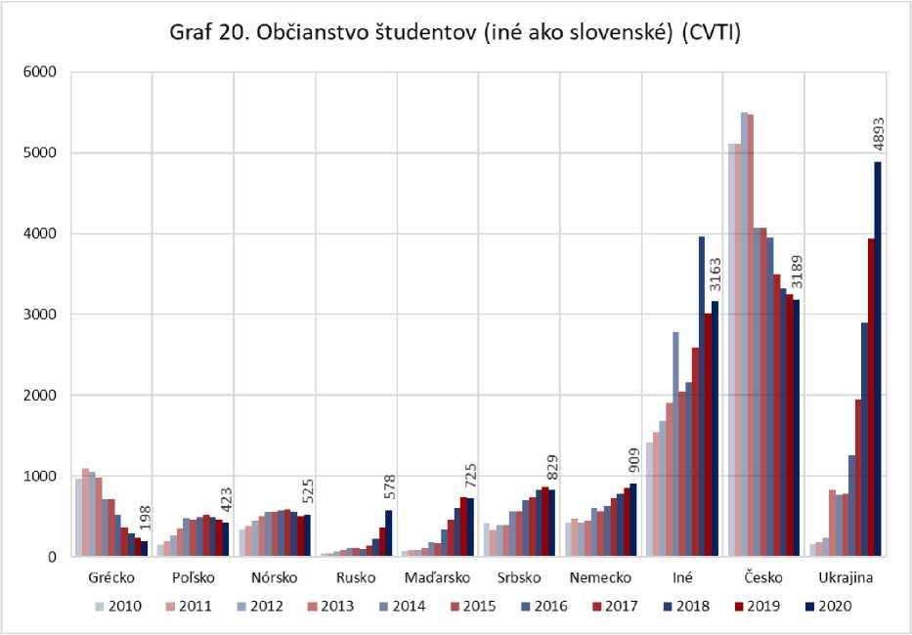
Figure 20. Citizenship of students (other than Slovak)

Countries that are both OECD and EU members.
Formerly UIPŠ (Convention of Education Information and Forecasts)
“Infostat is a subordinate organisation of the Statistical Office of the Slovak Republic with the status of contributory organisation. Its mission is to assist in the development of the statistical system of the Slovak Republic within the framework of national statistics through the solution of research and development tasks" (INFOSTAT SK — Infostat and its organisation).
source: Statistical Office of the Slovak Republic [numbers of 19-year-olds {datacube.statistics.sk} http://datacube.statistics.sk/%23!/view/sk/VBD_DEM/om7009rr/v_om7009rr_00_00_00_sk and born {datacube.statistics.sk} http://datacube.statistics.sk/%23!/view/sk/VBD_DEM/om7009rr/v_om7009rr_00_00_00_sk until 2020], the Research Demographic Centre at INFOSTAT (processed for the project “To Sense”) [prognosis of 19-year-olds until 2030 {https://analyza.todarozum.sk/docs/19061818140001xfj1/ }] https://analyza.todarozum.sk/docs/19061818140001xfj1/, 19-year-old estimates [own estimates in 2031-2038 based on the number of births]
https://analyza.todarozum.sk/docs/19061818140001xfj1/
https://data.oecd.org/chart/6xR6
http://uniregio.fvs.upjs.sk/pdf/zbornik/Gurnak Krizan Lauko.pdf
The groups of trade unions used in this review are based on CVTI data sources, where they have in the past been as follows established in a way based on the old network of fields of study( https://www.portalvs.sk/sk/studijne- fields/floods) — do not reflect thus, current splitting study trade unions (https://www.portalvs.sk/sk/studijne-odbory)
Statistics for the last calendar year (2020) not yet available at the time of publication of this overview
This starting point was largely due to the functioning of science and higher education during the period of socialism, when the emphasis was placed on the development of technical sectors, with social sciences and teachings being most suppressed in this system.
https://data.oecd.org/chart/6xx3
https://ec.europa.eu/eurostat/databrowser/bookmark/3d8d03b3-d7cb-4c83-875a-18849cc75019?lang=en
For FTE in 2011, data were reported as at 31. 12. 2011, as it was the first date with available data
“Full-time equivalent” — full-time equivalent
Source: Time series — colleges, CVTI SR (link)
HEI Employees Register, Graphs and Reports, Contract Size (link)
Source: Register of Employees of HEIs(https://www.portalvs.sk/regzam/stats/ratio), N.B.: in 2011, the number of teachers’ contracts was reported as at 31. 12., in other years already as of 31. 10th, as this data only began to be collected from that date.
OECD Data — Students per Teachings Staff (https://data.oecd.org/teachers/students-per-teaching-staff.htm)
https://cedos.org.ua/en/articles/ukrainski-studenty-u-slovachchyni-polityky-zaluchennia-intehratsii-ta- motyvatsiia-i-plany-studentiv#ukr
Countries that are members of both the EU and the OECD
OECD, Education at Glance 2021 — Figure B6.2. Incoming student mobility in tertiary education, by level of study (2019) https://stat.link/cwlnud
In the Academic Quarter- hour survey, only 25.6 % of all respondents reported that the majority of subjects (almost all subjects + most subjects) were also attended by foreign and/or mobile students with them, with more than half of respondents choosing the option “nearly no subjects” (51.7 %), the rest then chose the “minority of subjects” option (22.7 %).
Out of a total of 1179 foreign students (Ukrainian citizenship in the whole research sample, 510 respondents) who took part in the Academic Quarter-hour survey, 15.3 % said they did not know Slovak, 22.3 % qualified as beginners, and 20.4 % as slightly advanced. Only less than 42 % is therefore more than moderately advanced.

