Brief instructions for submitting an application for the assessment of the compliance of the internal quality assurance system in the information system of the Slovak Accreditation Agency for Higher Education

Content

Introduction ............................................................................................................................................1
1. Log in to the Information system ........................................................................................................ 1
2. Creating an Application ....................................................................................................................... 2
3. Editing the Application ....................................................................................................................... 3
4. Validating the Application ...................................................................................................................5
5. Closing, submitting the Application, and paying the fee .................................................................... 7

Introduction
These instructions are addressed to the applicant – persons entitled to submit applications for the assessment of the compliance of the internal system of a higher education institution pursuant to § 24 of Act No. 269/2018 Coll. in the information system of the Slovak Accreditation Agency for Higher Education (hereinafter also referred to as "SAAHE IS").

1. Log in to the information system
If a higher education institution does not have access to the Agency‘s information system, it shall apply for access via ziadosti@saavs.sk, informing the Agency of the name, surname, e-mail address and telephone contact of the person authorised to enter the SAAHE IS on behalf of the higher education institution and to submit applications.

The Agency will send the access data to the SAAHE IS to the authorised person by e-mail.
The e-mail shall be in the following form:
From: notifikacia@is.saavs.sk
Sent: Wednesday, February 12, 2022, 8:36 PM
To: email address
Subject: Activation of your SAAHE IS account
Your account information:
• Login name:
• Password:
Login: https://is.saavs.sk/login

Please note: Access data can only be handled by the authorised person to whom the access data has been assigned. Account information may not be disclosed to another person. The authorised person clicks on the link https://is.saavs.sk/login and logs in to the SAAHE IS with the login name and password sent to him/her.
2. Creating an Application
The authorised person shall submit an Application for the assessment of the compliance of the internal quality assurance system in the module

Submission of an application.
The Submission module contains:
Overview – contains brief instructions on how to create an application.
Activity – a log of the authorised person‘s actions in the SAAHE IS.
List – a list of pending, upcoming, and submitted applications of the authorised person.

Create new - access to application forms.

To access the application forms, after entering the Application module, it is necessary to click on the "Create New" menu.

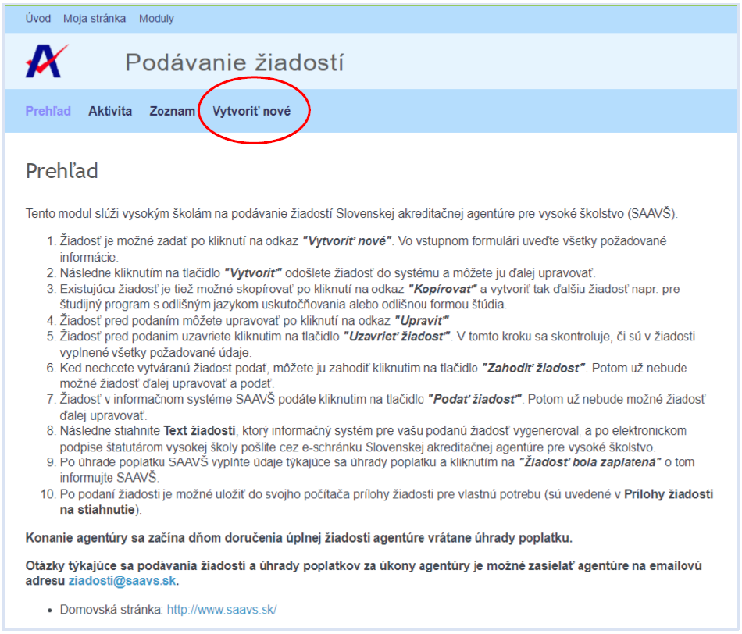

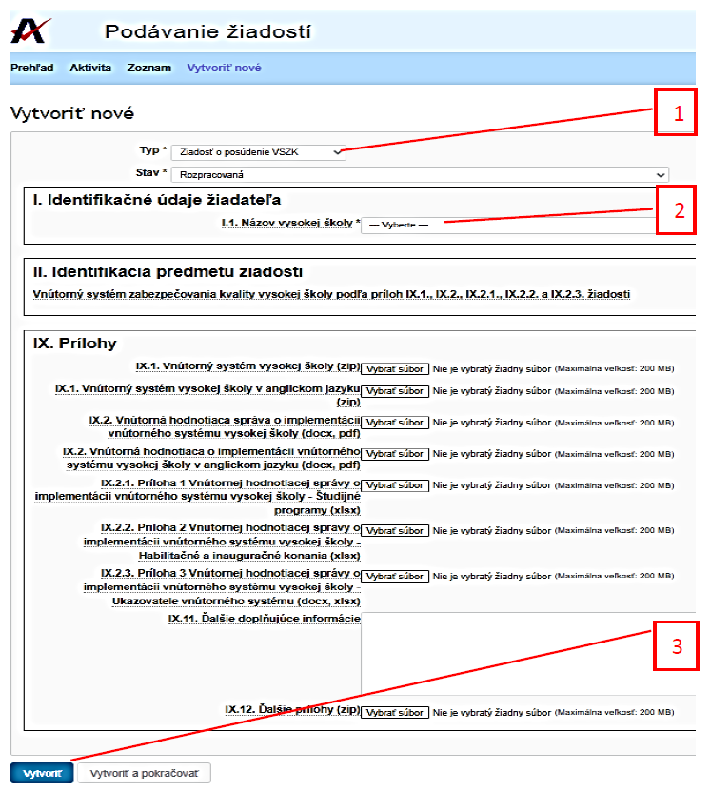
Application procedure:

Step 1: In the "Type" field, select the value Application for the assessment of IQAS
Step 2: Select a value in the "Higher Education Institution Name" field.
Step 3: Create an application.

It may take a few minutes to create the application.
The SAAHE IS generates a template for Annex 1 and Annex 2 of the Internal Evaluation Report on the implementation of the IS of the HEI (hereafter referred to as IER IS). System Implementation Assessment Report (hereafter referred to as ISIR).
See the Manual for the preparation of the internal evaluation report on the implementation of the internal system of the higher education institution.

3. Editing the Application
Step 4: After creating the application, the SAAHE IS will offer the HEI a template for Annex 1 of the IER IS with the data from the SP register. After downloading the form, the HEI will add additional data to the individual SPs in accordance with the instructions in Annex 1 of the IER IS Processing Manual. The Manual for the preparation of the IER IS
Step 5: Until the date of availability of the new register of HP and IP of the Ministry (expected date September 2022), the SAAHE IS generates the table of Annex 2 of the IER IS without the register data. The applicant shall complete all columns of the annex in accordance with the accredited procedures.

Step 6: The application can be further edited and attachments inserted in the application editing mode (Edit Application).
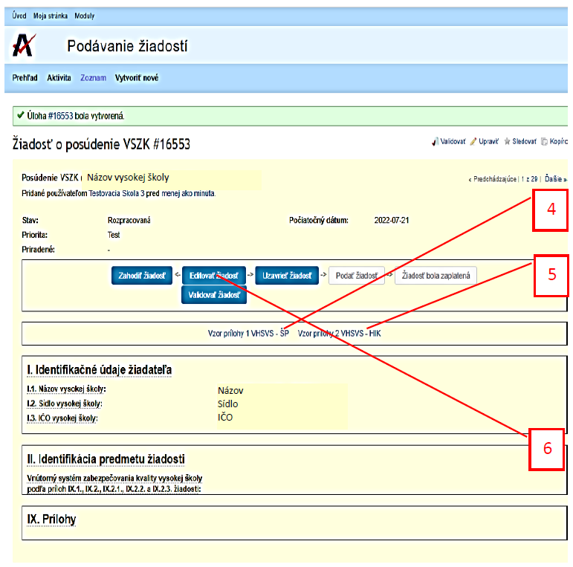

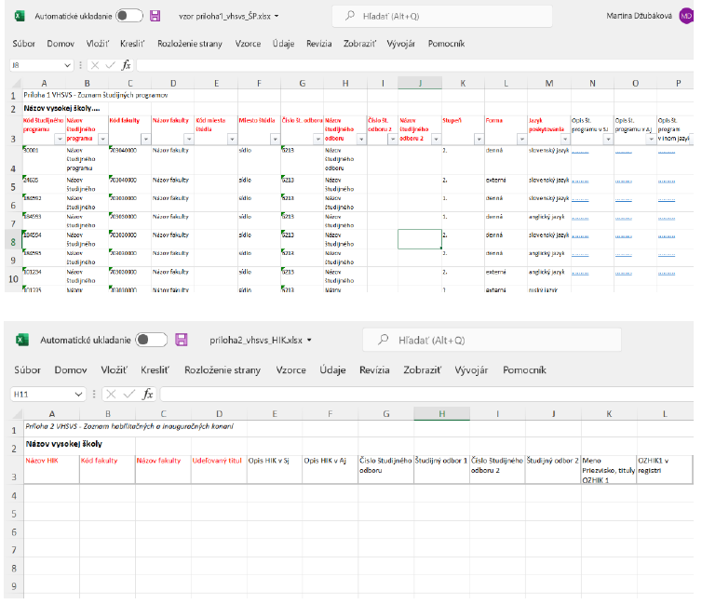
Annex 1 of the IER IS – List of study programmes.
The HEI may generate Annex 1 in its own information system according to Annex 1 of the Manual for the preparation of the IER IS

Annex 2 of the IER Is –
List of habilitation and inauguration proceedings.
The HEI may generate Annex 1 in its own information system according to Annex 2 of the Manual for the preparation of the IER IS

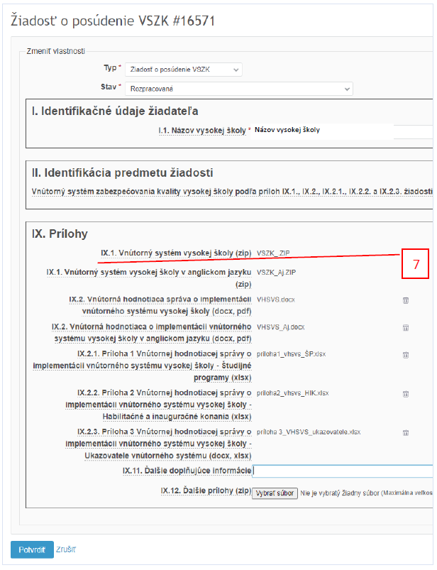
Step 7: Inserting the annexes.
The application shall be accompanied by:
- Internal system of the higher education institution (zip)
- Internal system of the higher education institution in EN (zip)
- Internal evaluation report on the implementation of the internal system of the HEI (docx, pdf)
- Internal evaluation report on the implementation of the internal system of the HEI in EN (docx, pdf)
- Annex 1 of the Internal evaluation report on the implementation of the internal system of the HEI – Study programmes (xlsx)
- Annex 2 of the Internal evaluation report on the implementation of the internal system of the HEI – Habilitation and Inauguration Proceedings (xlsx)
- Annex 3 of the Internal evaluation report on the implementation of the internal system of the HEI – Internal System Indicators (docx, xlsx, pdf)
- Other annexes of the Internal evaluation report on the implementation of the internal system of the HEI (zip)
- Additional supplementary information to the application

Guidelines on the content of the SAAHE application and application annexes:
https://saavs.sk/sk/ziadost-o-posudenie-suladu-vnutorneho-systemu-zabezpecovania-kvality-podla-%c2%a7-24-zakona-c-269-2018-z-z-2/
After each modification of the application, the changes to the application must be confirmed by clicking the "Confirm" button at the bottom of the form.
4. Validating the Application
Step 8: The HEI is responsible for the accuracy of the application and the application annexes.
The SAAHE IS allows checking the formal correctness of Annexes 1 and 2 of the IER IS in the Validator tool.
The Validator tool can also be used repeatedly once changes to the application have been confirmed.
Validation can take several minutes depending on the size of the HEI’s internal system (number of SPs and HPs and IPs).
Once the validation process is completed, the SAAHE IS will send a notification to the user about the completion and result of the validation.
Depending on the result of the validation, the application annexes can be edited (discarded and re-uploaded) as long as the application is in the 'In Progress' state (i.e. the 'Close Application‘ operation is not performed).

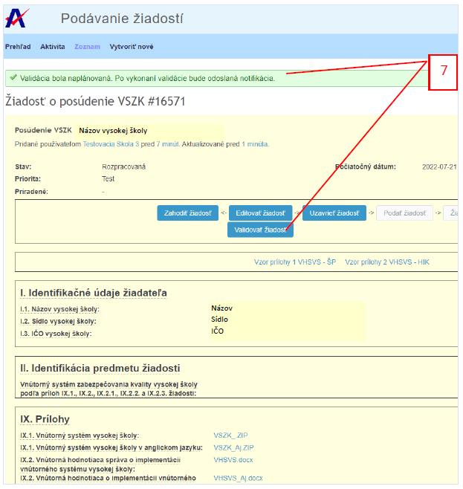
8

4.1. The validation process and content
After the validation has started, the IS shall announce: 'Validation has been scheduled. A notification will be sent after the validation has been performed." The validation is then run in the background.
When the validation is complete, a validation log note is added to the application (in the application history section) and the IS sends a notification to the user's e-mail.
1. The SAAHE IS checks that the annexes are attached to the application and that they are in the correct format (xlsx).
(2) The SAAHE IS shall check the formal correctness of Annex 1 of the application:

A/ Check that only the lines with the indicated SP code are listed.
If not, an error is printed: "There are NNN rows without code in the list".
B/ Check that the data in each column is in the correct format. If there is a problem with any SP, an error is printed: "SP is invalid: CODE......" followed by a more detailed description of the problem with the column identification:

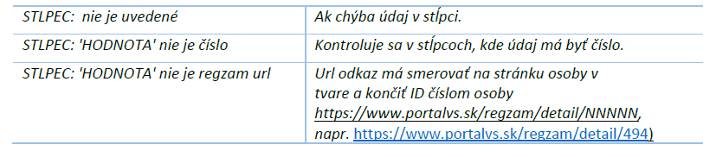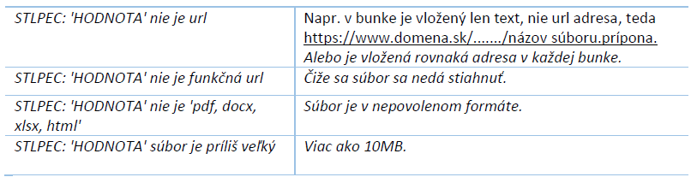
If there are more than 10 bad lines, the check is not continued and an error is printed: "More than 10 invalid SPs have been detected. Validation was terminated prematurely." Once the annex has been corrected, the validation can be restarted.
C/ Check that the SPs listed in Annex 1 are those that are currently in the curriculum register. If another programme is listed in the annex (in addition) the validator will print an error: "The SP is extra: CODE..." If a programme is missing the validator will print an error: "The SP is missing: CODE..."
D/ The data in the list is compared with the data in the register (by SP code). If a difference is found, an error "SP differs: CODE...." is printed, followed by a list of the data that differ:
COLUMN: 'VALUE' != 'REGISTRY VALUE'
If there are more than 10 distinct rows, the check is not continued and an error is printed: "More than 10 different SPs have been detected. Validation was terminated prematurely." Once the annex has been corrected, the validation can be restarted.
E/ If no errors were detected during the validation, "Validation of 'IX.21. Annex 1 of the Internal ER' was performed without errors" is printed.
3. Until the date of availability of the new register of HCs and ICs of the Ministry of Education and Science, Research and Sport of the Slovak Republic (expected date September 2022), the validator only verifies whether Annex 2 is inserted in the SAAHE IS. Its formal correctness will be verified by the applicant by comparing it with the information on the HE portal (https://www.portalvs.sk/sk/hai).

The applicant is responsible for the completeness and correctness of the application. Once the errors in the annexes have been corrected, it is possible in the editing mode of the application, to delete the original file (via the "trash" icon  on the right) and upload the corrected file. The Validator can be used again to verify the correctness.

5. Closing, submitting the Application and paying the fee
Step 9: When editing is complete, the applicant closes the application (switching to the "Close Application" state).
Closure is possible if the applicant has uploaded all annexes to the SAAHE IS in the allowed format.
Once the application has been closed, the application cannot be further edited. If
the applicant finds deficiencies, he/she can copy the application and continue editing the new application. The original application may be discarded.“).

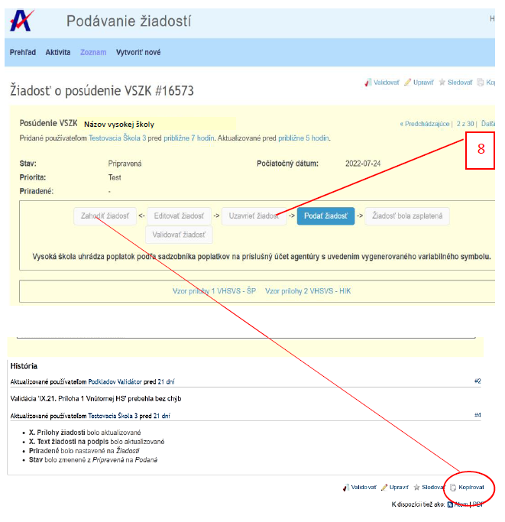
9
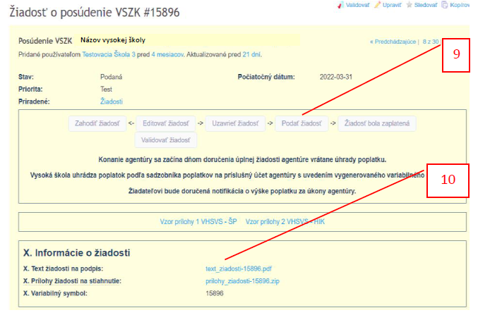
11
10
8
Step 10:
Once the application is closed, the HEI will submit the application ("Submit Application").

Step 11: The SAAHE IS generates the text of the application (pdf), which the HEI submits via the e-repository signed with the electronic signature of the statutory body.

The applicant will then be notified of the amount of the fee in accordance with the Fee Schedule. The fee notice may be received within a few days, depending on the completeness and extent of the application.

